

**Tribhuvan University**

**Faculty of Humanities and Social Studies**

**BLOOD BANK MANAGEMENT SYSTEM**

**A PROJECT REPORT**

**Submitted to:**

**Department of Computer Application**

**Prime College**

***In the partial fulfillment of the requirements for the bachelors in Computer***

***Application***

Submitted by:

Biplap Neupane (6-2-410-7-2020)

Sita Kumari Shrestha (6-2-410-27-2020)

August 2023 A.D

**Under the supervision of**

**Mr. Radha Krishna Gajurel**



**Tribhuvan University**

**Faculty of Humanities and Social Studies**

**BLOOD BANK MANAGEMENT SYSTEM**

**A PROJECT REPORT**

**Submitted to:**

**Department of Computer Application**

**Prime College**

***In the partial fulfillment of the requirements for the bachelors in Computer***

***Application***

Submitted by:

Biplap Neupane (6-2-410-7-2020)

Sita Kumari Shrestha (6-2-410-27-2020)

August 2023 A.D

**Under the supervision of**

**Mr. Radha Krishna Gajurel**



**Tribhuvan University**

**Faculty of Humanities and Social Science**

**Prime College**

# **Supervisor’s recommendation**

I hereby recommend that this project is prepared under my supervision by Biplap Neupane and Sita Kumari Shrestha entitled “**Blood Bank Management System**” in the partial fulfillment for the degree of Bachelor of Computer Application is recommended for the final evaluation.

**Mr. Radha Krishna Gajurel**

**SUPERVISOR**

**Prime College**



**Tribhuvan University**

**Faculty of Humanities and Social Science**

**Prime College**

# **LETTER OF APPROVAL**

This is to certify that this project is prepared by Biplap Neupane and Sita Kumari Shrestha entitled “**Blood Bank Management System**” in the partial fulfillment for the degree of Bachelor of Computer Application has been evaluated. In our opinion it is satisfactory in the scope and quality as a project for the required degree.

|  |  |
| --- | --- |
| **Mr. Radha Krishna Gajurel**  **Supervisor**  **Prime College, Khusibun** | **Er. Rolisha Sthapit**  **BCA Co-Ordinator/ Internal Examiner**  **BCA Department**  **Prime College, Khusibun** |
|  | **Basanta Chapagain**  **External Examiner** |

# **ABSTRACT**

The Blood Bank Management System is designed to provide an online platform to bridge the gap between donor and patient who are in need of blood. This system helps user to login to the system by filling out the registration form and then by using the registered username and password one can access the system either it is donor or the patient. Once they are logged in to the system, they will be able to view the blood in storage, what sort of blood are required. This system is developed using HTML, CSS, JavaScript, PHP and MySQL. On the other hand, only few people will be given the admin credentials using that one access the admin dashboard where they can see all the logged in blood request and interested donor data. They will be able to process the requests, manage the database where they can manipulate the data. Once the admin processes the request, users can see the changes in their profile that their requests has been processed and if there are stocks or not. Hence, this system is capable of managing the blood donation request as well as blood request.

*Keywords: HTML, CSS, JavaScript, PHP, MySQL*

# **ACKNOWLEDGEMENT**

For the partial fulfillment of the project in this semester, we would like to express our sincere gratitude to everyone who had directly and indirectly helped us to complete this project. There were times when we thought that this project was too difficult or we may not be able to complete this in time, but we are really thankful to everyone who had encouraged, inspired and helped us to complete this project. We are really thankful to our supervisor **Mr. Radha Krishna Gajurel** sir and our coordinator **Er. Rolisha Sthapit** who helped us in our each and every difficulty that aroused during our project.

We would also like to express our heartfelt gratitude to all the classmates who were always inspiring us to continue with the project and reminded us the competition every time. I am also grateful to all our professors for their guidance and support throughout the project.

Finally, we are grateful to Tribhuvan University for giving this opportunity via the course of Computer Application to help me understand the project ethics at this early stage and helped me develop my skills and knowledge through this project.

Biplap Neupane

Sita Kumari Shrestha

# **TABLE OF CONTENTS**

SUPERVISOR’S RECOMMENDATION i

LETTER OF APPROVAL ii

ABSTRACT iii

ACKNOWLEDGEMENT iv

TABLE OF CONTENTS v

LIST OF ABBREVIATIONS vii

LIST OF TABLES viii

LIST OF FIGURES ix

CHAPTER 1 INTRODUCTION 1

1.1 Introduction 1

1.2 Problem Statement 1

1.3 Objectives 2

1.4 Scopes and Limitations 2

1. 4.1 Scopes 2

1.4.2 Limitations 2

1.5 Development Methodology 2

1.6 Report Organization 4

CHAPTER 2 BACKGROUND STUDY AND LITERATURE REVIEW 5

2.1 Background Study 5

2.2 Literature review 5

CHAPTER 3 SYSTEM ANALYSIS AND DESIGN 7

3.1 System Analysis 7

3.1.1 Requirement Analysis 7

3.1.2 Feasibility Study 9

3.1.3 Data Modeling 12

3.1.4 Process Modeling 13

3.2 System Design 16

3.2.1 System Architecture 16

3.2.2 Database Schema Design 17

3.2.3 Interface Design (UI Interface/ Interface Structure Diagrams) 18

3.2.4 Physical DFD 19

CHAPTER 4 IMPLEMENTATION AND TESTING 21

4.1 Implementation 21

4.1.1 Tools Used (CASE tools, Programming Languages, Database Platforms) 21

4.1.2 Implementation Details of Modules (Description of Procedures/ functions) 21

4.2 Testing 22

4.2.1 Unit Testing 22

4.2.2 System testing 26

CHAPTER 5 CONCLUSION AND FUTURE RECOMMENDATIONS 30

5.1 Lesson learnt/ Outcome 30

5.2 Conclusion 30

5.3 Future Recommendation 31

REFERENCES 32

APPENDIX

# **LIST OF ABBREVIATIONS**

**CSS** Cascading Style Sheet

**DFD**  Data Flow Diagram

**ERD** Entity Relational Diagram

**HTML** Hypertext Markup Language

**JS** JavaScript

**PHP**  Hypertext Preprocessor

**SQL**  Structure Query Language

# **LIST OF TABLES**

Table 3. 1 Gantt Table 11

Table 4. 1 Donor Registration 22

Table 4. 2 Request Blood 24

Table 4. 3 Search Blood details 26

Table 4. 4 User Interface 27

Table 4. 5 Admin Interface 28

# **LIST OF FIGURES**

Figure1. 1 Iterative Methodology of Blood Bank Management System 3

Figure 3. 1 Use case diagram of Blood Bank Management System 8

Figure 3. 2 Gantt Chart of Blood Bank Management System 12

Figure 3. 3 Entity Relationship Diagram of Blood Bank Management System 13

Figure 3. 4 Context level Diagram of Blood Bank Management System 14

Figure 3. 5 Level 1 Data Flow Diagram of Blood Bank Management System 15

Figure 3. 6 System Architecture of Blood Bank Management System 17

Figure 3. 7 Database Schema Design of Blood Bank Management System 17

Figure 3. 8 Interface Design of Blood Bank Management System 18

Figure 3. 9 UI Interface of Blood Bank Management System 19

Figure 3. 10 Physical Diagram of Blood Bank Management System 19

# **CHAPTER 1**

# **INTRODUCTION**

## **1.1 Introduction**

Blood Bank Management System is a browser-based solution that is designed to store, process, retrieve and analyze information concerned with the administrative, inventory management. This project is a web-based application to make an initial step to something we lack or we are need of. This application allows the user to store and see the storage data themselves. As soon as the donor and patient are registered, they will be able to use the application with the same user’s name through the life time. Any subsequent donations made by the same donor automatically got linked up with the same user’s name. And those who takes the blood with the help of this application will also be linked up with the database.

This application provides information of stock inventory to the user. They can get the store record of blood present in the bank. This application allows user to request for blood they need and they will get the information of having the required blood in the bank or not.

This application provides the secure environment to work inside the application without being their personal information leaked or misused. It includes donor screening, storage and issue of the unit. This system manages all the activities from blood collection separately. There will be different page for donor and receiver where the donor can view the page of blood donation information whereas the receiver can only view the available blood in the bank and request for the necessary blood.

In the process of development of this application, we have used HTML and CSS to create a user interface, providing a visually appealing and intuitive experience for users. JavaScript is used for handling the client-side interactivity and PHP is used for managing server-side processing and database interactions. And MySQL is used for storing, retrieving, and managing data for this webpage development.

## **1.2 Problem Statement**

The development of a blood bank management system presents several challenges that need to be addressed to enhance the efficiency and effectiveness of blood bank operations. Firstly, there is high reliance on manual and paper-based processes that might create inefficiencies, errors and delays. Maintaining accurate donor records, tacking inventory in real-time managing related data becomes cumbersome and prone to human error. Secondly, manual processes make it difficult to maintain up-to-date donor information, track donation history, and engage with potential donors effectively. This limitation adversely affects the availability of a diverse and reliable donor pool.

The existing blood bank management systems suffers from manual and paper-based processes lacks of standardization and inefficient donor management. Addressing those challenges through the implementation of an advanced blood bank management system is crucial to ensure a more efficient, safe and effective blood supply management, ultimately saving lives and improving patient care.

## **1.3 Objectives**

This applied research aims to develop, design and implement online blood bank management system. This web-based application provides the following objectives:

* To check the availability of blood bags anytime.
* To support users to find the matching blood types online.
* To let user, know about their id login, blood request via email.

## **1.4 Scopes and Limitations**

### **1. 4.1 Scopes**

In the context of Nepal, there are hundreds of organizations for blood collection but there is no such platform where they are registered and can be viewed easily. But if these same things can be online then it will be much easier and reliable to find the blood in short period of time and the victims can be saved fast too.

### **1.4.2 Limitations**

* This application does not cover the actual blood collection activities.
* Blood donor can mistake to enter their blood types correctly.

## **1.5 Development Methodology**

A development methodology is a systematic approach or framework used in software development to guide the process of creating software or web applications. It provides a structured and organized way for a team to plan, design, develop, test, and deliver a software product. Development methodologies define the processes, tasks, roles, and responsibilities that team members need to follow throughout the project's lifecycle. There are different models or methods used or followed during software development life cycle (SDLC) processes such as the waterfall model, prototyping model, spiral model and others based on the nature or objective of the software.

As maximum requirements for the project were discussed and finalized before starting working on the project and one stage would come after the completion of the previous steps, the author decided to use the waterfall model for the completion of the project.

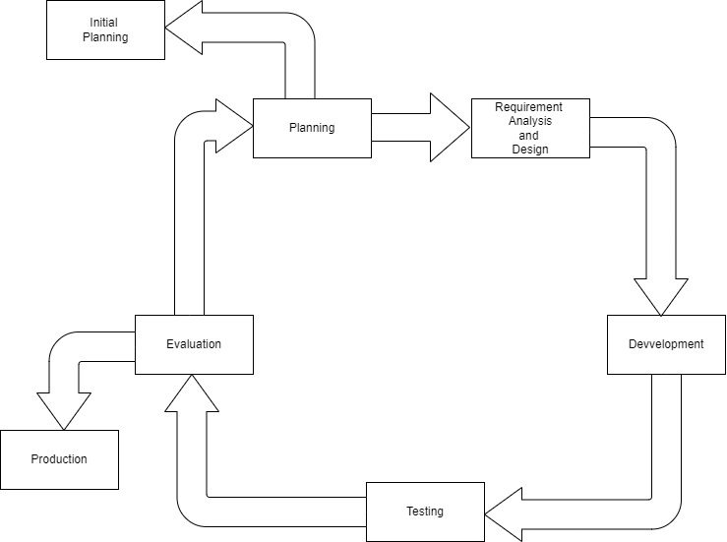

**Figure1. 1 Iterative Methodology of Blood Bank Management System**

1. **Planning:** In this process, the project’s plans were defined and aligned the overall project objectives.
2. **Requirement analysis** **and Design:** During this step, it was focused on the technical requirement of the project.
3. **Development:**  With inputs from the requirement analysis and system design, the system is first developed in small programs called units, which are integrated in the next phase. Each module of the system is developed independently, following coding standards and guidelines. Each unit is developed and tested for its functionality, which is referred to as Unit Testing.
4. **Testing:** All the units developed in the implementation phase are integrated into a system after testing of each unit. Post integration the entire system is tested for any faults and failures. This phase includes various levels such as unit testing, system testing.
5. **Evaluation:** After the testing of the project, the success of the project and the requirements were either meet or not was evaluated.
6. **Initial Planning:** After evaluating all the prepared project, there was some of the limitations that should be changed so it was planned once again and repeat the process.

## **1.6 Report Organization**

This report starts with Chapter 1 as the introduction of the blood donation and receiving the blood easily by getting in contact with the donor online. It is stated with the problem statement, report organization, objectives, scopes, limitations of the project and which methodology is used for the development process.

Chapter 2 begins with the background study of the project about how the people are in need of this project in the context of this country and is followed with a literature review of different other similar projects done by others.

Chapter 3 discuss about the data modeling and process modeling technique that are used to give the information about the system requirement and feasibility study. The system design used are Use Case Design, Gantt Chart, Entity Relationship Diagram, Process modeling (Level 0 and Level 1 DFD), System Architecture, database schema design, interface design and Physical DFD.

Chapter 4 explains about the implementations and testing done in this project. It provides a brief introduction about the tools used in this project’s front end, back end and purpose of it. The testing and the modules are also explained in the same part.

Chapter 5 includes the conclusions of how the project is accomplished, its findings and many more. It also discusses the recommendations for the future enhancements of the project. In conclusion, this chapter overview’s purpose of doing this project including its scopes and objectives with its limitations.

# **CHAPTER 2**

# **BACKGROUND STUDY AND LITERATURE REVIEW**

## **2.1 Background Study**

There are a lot of communication gap among patients and donors, blood banks and the hospitals. If there is someone who needs blood then firstly, he/she start to search the blood within their family member and relatives, then contact to nearest hospitals and blood banks. But sometime they might not get blood in time which may risk the patient’s life. Hence the is need of a blood bank management system.

The application “Blood Bank Management System” offers functionalities to quick access to register the donor and collect donor or blood directly from the blood bank. It enables monitoring of the result and performance of the blood donation activity.

In the context of Nepal, there is need of an online blood bank manage system which can be able to help people efficiently. This will be helpful to both donors and patients.

## **2.2 Literature review**

A blood bank plays a crucial role in ensuring an adequate and safe supply of blood for medical procedures and emergencies. To effectively manage the diverse processes involved in a blood bank, the implementation to robust Blood Bank Management System becomes essential. This literature review aims to explore the existing research and developments and in the field of Blood Bank Management System to provide insights into the current state of the art and identity potential areas for improvement.

In this literature review some of the projects are explained. All these projects are on blood bank management systems which means how to manage blood banks, how a recipient can access to blood more easily than previous old traditional methods.

In “Blood Bank Information System Based on Cloud in Indonesia” by S. Mufaqih, Abiyyu Fawwaz Kanz, S. Ramadhan, Afajar (2020). They proposed a system in which a connecting system that integrates Indonesian society who can be personal donor to help blood supply availability of UTD PMI using BBIS (Blood Bank Management System) based on Cloud computing [1].

In “Social Challenges and Opportunities in Blood Bank Distribution in India” by Dhiviya Rose (2020). They discuss about an analysis report of blood banks about Blood Transfusion System in India is present and blood bank data available in Indian Government Portal study concluded that the blood banks are ununiformed in its distribution to the population of states and union territories [2].

In “Modeling and Analysis of Distribution of Blood Stock to Healthcare Units” by Pratiksha Patil, P. Ray, Esha Saha (2018). They introduced a system in which an integrated supply chain and distribution system as an extended enterprise is to be developed for addressing the problems related to mismatch between supply and demand of blood stocks at a particular period of time with respect to a given population of patients in a location. In this model, the blood banks considered are clustered using k-means clustering technique based on the distances between the blood banks [3].

In “IOT based Blood Bank Maintains System” by Dr. Shilpa, P. Kodgire, Soni Gaikwad, Kiran Khandagle (2022). In this system it is discussed about how the mentioned system is used in administer and monitors the entreaty and forwarding of the blood is nominated as a blood bank. Its main idea is to is to give the blood to the cases with minimum error in blood transfusion [4].

In “Online Blood Bank Management System” Mohd Saif Abbas, Sheenu Rizvi (2022). They discussed about the system where their framework can be utilized to track down the required measures of blood in crisis circumstances from either blood donation centers or even blood benefactors. Their goals of proposing such a framework were to annul the frenzy made during a crisis due inaccessibility of blood. The objective of this undertaking was to give individuals a solitary answer for all the blood-giving and getting issues all at one place in a solitary snap [5].

# **CHAPTER 3**

# **SYSTEM ANALYSIS AND DESIGN**

## **3.1 System Analysis**

System analysis is a crucial phase in the software development process that involves studying and understanding the requirements and specifications of a proposed software system. It is the process of examining, identifying, and defining the needs of the intended users and stakeholders for a new or existing system. The primary goal of system analysis is to ensure that the resulting software system will meet the desired objectives and effectively address the identified needs.

### **Requirement Analysis**

Requirement analysis is a systematic process of studying, documenting and understanding the needs, expectations and constraints of a stakeholder for a system or application. It is a critical phase in software development lifecycle, as it forms the basis for designing and building the right solution that meets the desired objectives and user requirements.

The output of the requirement analysis serves as the basis for subsequent phase of software development, including system design, coding, testing, and deployment. It is essential to invest time and effort in thorough requirement analysis to avoid costly rework, improve the chances of project success, and deliver a software system that satisfies stakeholders' expectations.

1. **Functional requirement**

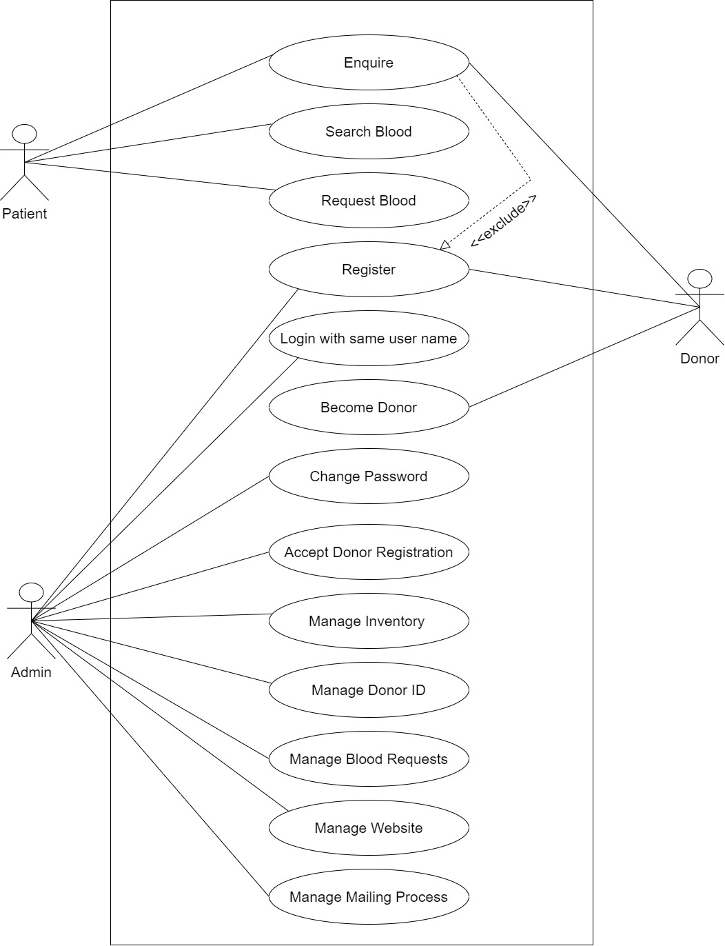

**Figure 3. 1 Use case diagram of Blood Bank Management System**

1. **Registration:** Registration is always open to all the visitors in blood bank management System. Users can register on this website by filling up the form and entering the required details.
2. **Login:**  Admin can login with username and password they have entered during the registration process.
3. **Become Donor:**  One can become a donor if he/she is ready to donate blood by following registration process.
4. **Enquire:**  All the visitor can enquire about the blood stock in blood bank and which types of blood are available without logging in.
5. **Request for Blood:**  When the patient is in need for blood, they can always request for the blood by entering the required blood type without logging in.
6. **Change Password:** Users can change password if they forget their previous password of their account.
7. **Non-functional Requirement**
8. **User-friendly:** Blood bank management system is a user-friendly web-application. One does not need any professional skill to use the website. Person with basic knowledge and skills of computer can easily use this web application.
9. **Simple and easy to use:** Blood bank management system uses a simple design as well as simple language to improve the user friendliness of the web application.
10. **Easy Access:** Blood bank management system can be accessed anytime anywhere with the internet connection on the device.
11. **Responsive:** Blood bank management system is responsive which is proven to be beneficial to the people living in areas with limited access of the computer.

### **3.1.2 Feasibility Study**

After doing the project ‘Blood bank management system’, study and analyzing all the existing or requires functionalities of the system, the next task is to do the feasibility study for the project. It includes all the consideration of all the possible ways to provide a solution to the given problem.

1. **Economic feasibility**

The specific requirements and solutions have been identified to weight the cost and benefits of the alternatives. The hardware and software used are simple and there is no other additional requirement. It is based on the existing system, so the cost will be minimum. The only cost that will be encountered are printing cost, paper costs and internet and electricity expenses.

1. **Operational Feasibility**

The main focus is on providing the information about the stock remaining in the blood bank. It is an internet-based application so the websites may not load in the case of internet disconnection. This application is developed with the simple concept with user-friendly interface which can be used easily.

1. **Technical Feasibility**

Technical feasibility study is the evaluation of the hardware and software and how it meets the needs of the proposed system. This application is technically feasible as high expert person is not required to use this application.

**Software Requirements:** This application is compatible with any browsers. This system itself is a platform independent and it can be run on any Operating System.

**Hardware Requirements:** This project is developed and ran on Intel Core i5: 11th generation. Although the system runs fine on i3 processors, for smooth implementation. The proposed hardware and software requirements are feasible for almost all the processors and aren’t too expensive. Therefore, this project is technically feasible.

1. **Schedule Feasibility**

Schedule feasibility is one of the key aspects assessed during the early stages of a project to determine whether the proposed project timeline is achievable and realistic. This includes the project schedule and the time allocated for their completion. The Gantt Table and Gantt Chart are as follows:

**Table 3. 1 Gantt Table**

|  |  |  |  |  |  |
| --- | --- | --- | --- | --- | --- |
| **Task** | **Start Date** | **End Date** | **Duration** | **Progress** | **Completed Days** |
| Documentation | 3-Mar-23 | 14-Aug-23 | 164 | 90% | 148 |
| **\*\*Iteration 1\*\*** | 7-Mar-23 | 15-Apr-23 | 39 | 90% | 35 |
| Planning | 7-Mar-23 | 10-Mar-23 | 3 | 85% | 3 |
| Requirement Analysis and  Design | 11-Mar-23 | 17-Mar-23 | 6 | 90% | 5 |
| Development | 18-Mar-23 | 28-Mar-23 | 10 | 75% | 8 |
| Testing | 29-Mar-23 | 4-Apr-23 | 6 | 80% | 5 |
| Evaluation  /Production | 5-Apr-23 | 15-Apr-23 | 10 | 100% | 10 |
| **\*\*Iteration 2\*\*** | 16-Apr-23 | 10-Jun-23 | 55 | 95% | 52 |
| Planning | 16-Apr-23 | 20-Apr-23 | 4 | 90% | 4 |
| Requirement Analysis and  Design | 21-Apr-23 | 28-Apr-23 | 7 | 95% | 7 |
| Development | 29-Apr-23 | 12-May-23 | 13 | 85% | 11 |
| Testing | 13-Mar-23 | 25-May-23 | 73 | 85% | 62 |
| Evaluation/  Production | 26-May-23 | 10-Jun-23 | 15 | 100% | 15 |
| **\*\*Final Iteration \*\*** | 11-Jun-23 | 9-Aug-23 | 59 | 90% | 53 |
| Planning | 11-Jun-23 | 17-Jun-23 | 6 | 100% | 6 |
| Requirement Analysis and  Design | 18-Jun-23 | 26-Jun-23 | 8 | 90% | 7 |
| Development | 27-Jun-23 | 15-Jul-23 | 18 | 79% | 14 |
| Testing | 16-Jul-23 | 25-Jul-23 | 9 | 95% | 9 |
| Evaluation/  Production | 26-Jul-23 | 9-Aug-23 | 14 | 100% | 14 |

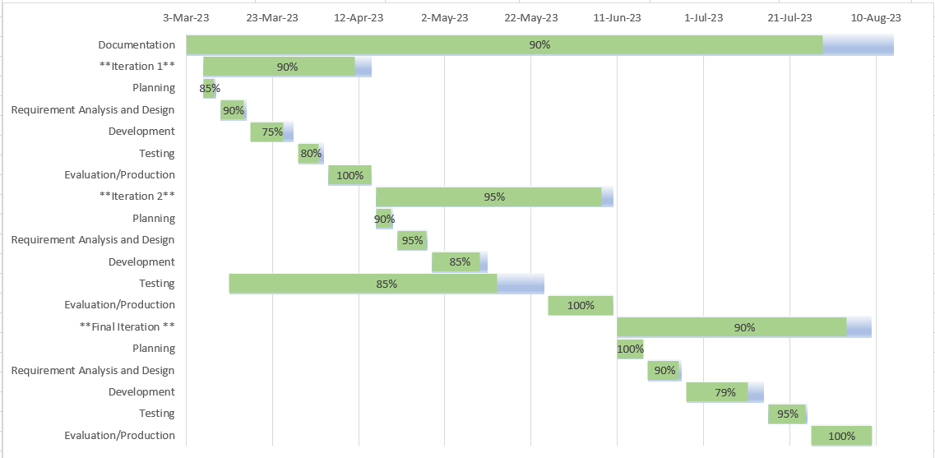

**Figure 3. 2 Gantt Chart of Blood Bank Management System**

### **3.1.3 Data Modeling**

A data modeling is the process of creating a conceptual representation of the data used in a software system or database. It involves defining the structure, relationships, and constraints of the data in a way that is easily understandable and implementable by developers and stakeholders. Data modeling is often carried out using specialized notation or tools like Entity-Relationship Diagrams (ERDs). These graphical representations help stakeholders visualize the data structure and relationships in an intuitive and easy-to-understand manner.

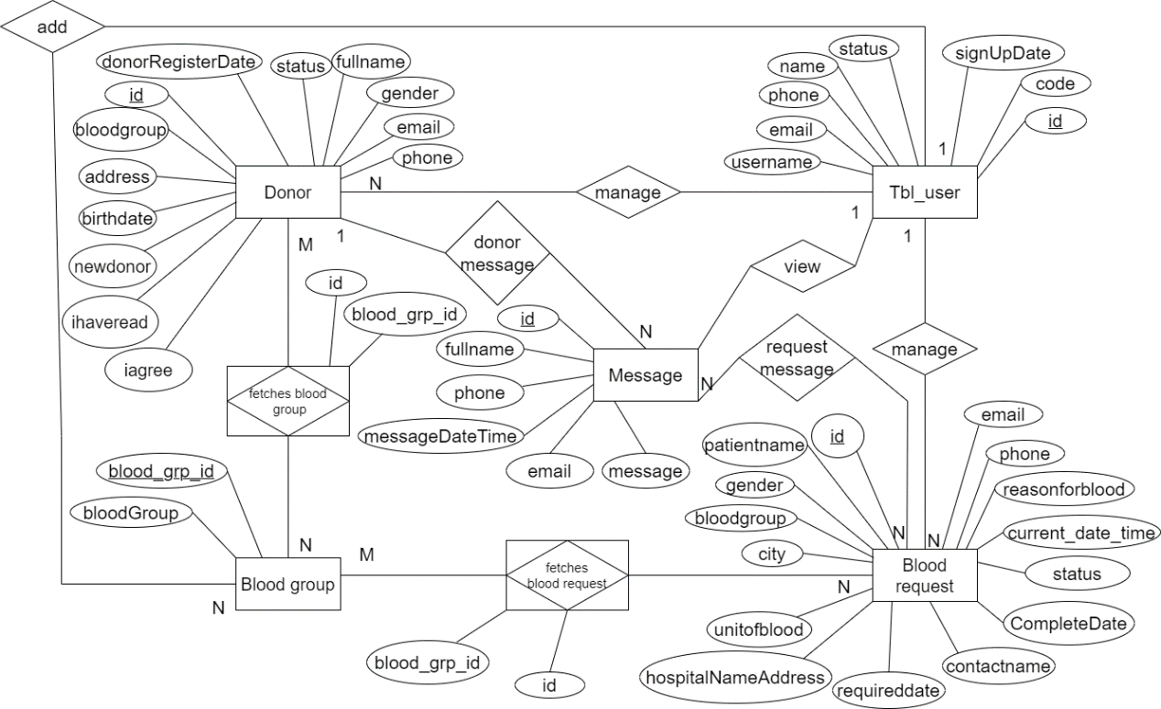

**Figure 3. 3 Entity Relationship Diagram of Blood Bank Management System**

This figure is a visual representation of database structures of the project about how the system works. Here, the entity tbl_user is represented as admin of the project who can manage the donors, blood requests and view the messages. Donors and Patients both can message including other visitors of the application. A donor can have multiple blood requests. A Blood Request is initiated by one Donor and can request a specific Blood Group. An Admin can send and receive multiple Messages.

### **3.1.4 Process Modeling**

A Data Flow Diagram can be referred as Process Model. It is a representation of the “flow” of a data through an information system. It is a significant modeling technique for analyzing and constructing information process illustrates this flow of information in a process based on the inputs and outputs.

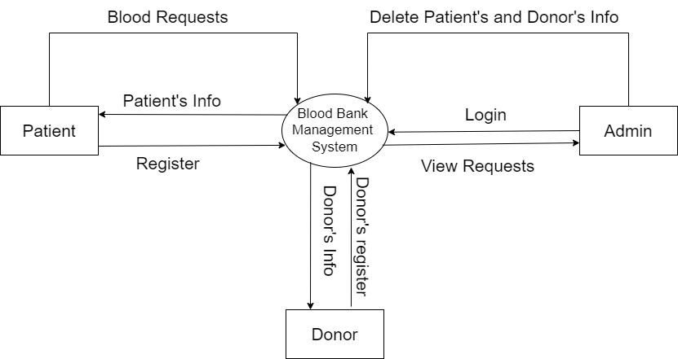

**Figure 3. 4 Context level Diagram of Blood Bank Management System**

The level 0 Data Flow diagram shows the most basic relationship among users and admin. It shows that a patient can enquire and request for blood, donor can register and donate blood and admin can view the request and manage the request as well as delete the patient’s and donor’s information.

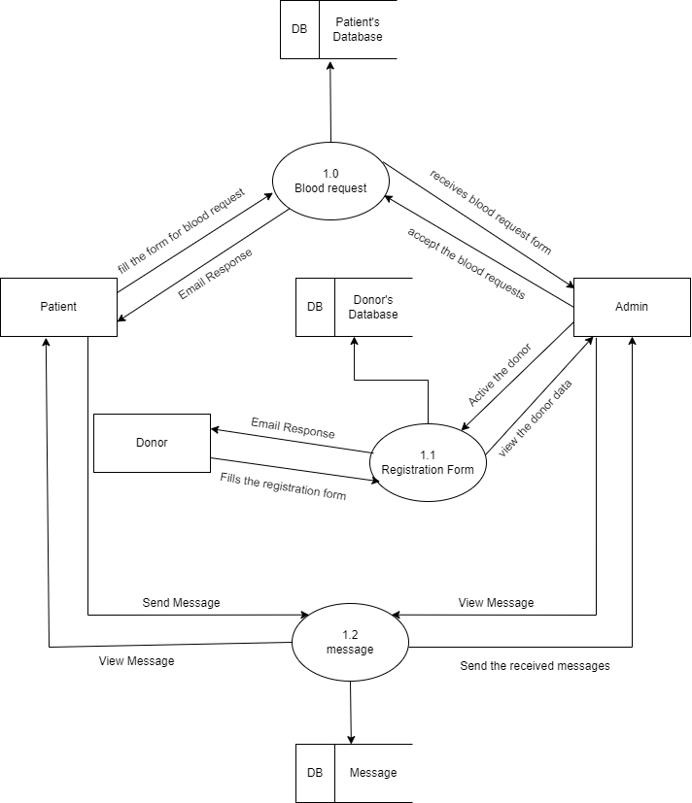

**Figure 3. 5 Level 1 Data Flow Diagram of Blood Bank Management System**

A level 1 DFD notates each of the main sub-processes that together form the complete system. This level provides a more detailed view of the system by breaking down the major processes identified in the level 0 DFD into sub-processes. Each sub-process is depicted as a separate process on the level 1 DFD. The data flows and data stores associated with each sub-process are also shown. It demonstrates how various modules interact and contribute to the overall functionality of the system.

## **3.2 System Design**

System design is the process of planning a new system or to replace the existing system. Simply, the design is like the blueprint for a building, that specifies all the features that are to be in the finished product.

System design phase follows system analysis phase. Design is concerned with identifying functions, data streams among those functions, maintaining a good record of the design decisions and providing a blueprint the implementation phase.

Design is the bridge between system analysis and system implementation. Several designs were created in the design phase of the project such as system architecture, database schema design, UI Interface and Interface Structure diagram, physical DFD.

### **3.2.1 System Architecture**

The system architecture of blood bank management system can be divided into three main layers: presentation layer, application layer, and database layer.

**Presentation Layer:** This layer is responsible for the user interface and provides an interactive environment for the user to interact with the system. The user interface can be designed using HTML/CSS and JavaScript.

**Application Layer:** This layer contains the business logic and data processing. It is responsible for processing user requests, validating user input, and executing the appropriate actions. The application layer is designed using a server-side programming language such as PHP.

**Database Layer:** This layer is responsible for storing all the data related to the blood bank management system. It is designed using a database management system such as MySQL. The database layer will store all the information related to donors, recipients, blood groups, inventory, and transactions.

The web server will host the application and allow users to access it through a web browser. The web server will be responsible for handling incoming requests and forwarding them to the application layer. Once the application layer has processed the request, the web server will return the appropriate response to the user.

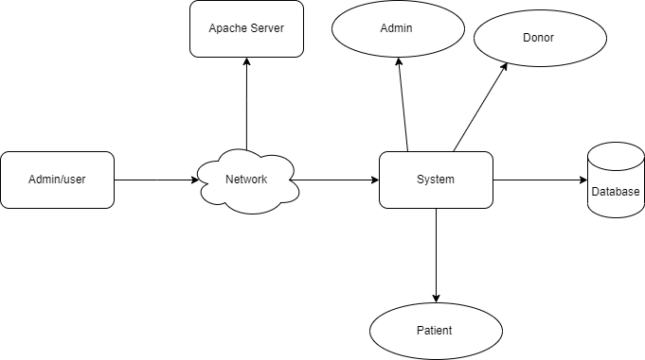

**Figure 3. 6 System Architecture of Blood Bank Management System**

### **3.2.2 Database Schema Design**

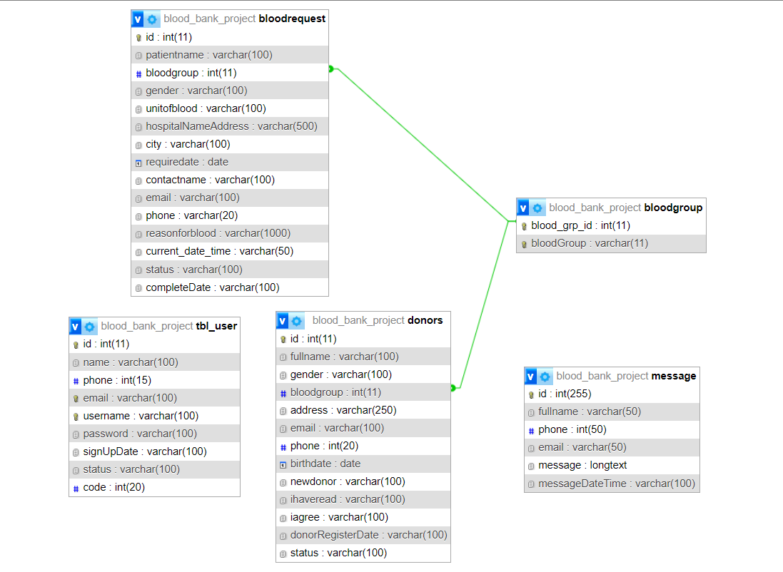

**Figure 3. 7 Database Schema Design of Blood Bank Management System**

### **3.2.3 Interface Design (UI Interface/ Interface Structure Diagrams)**

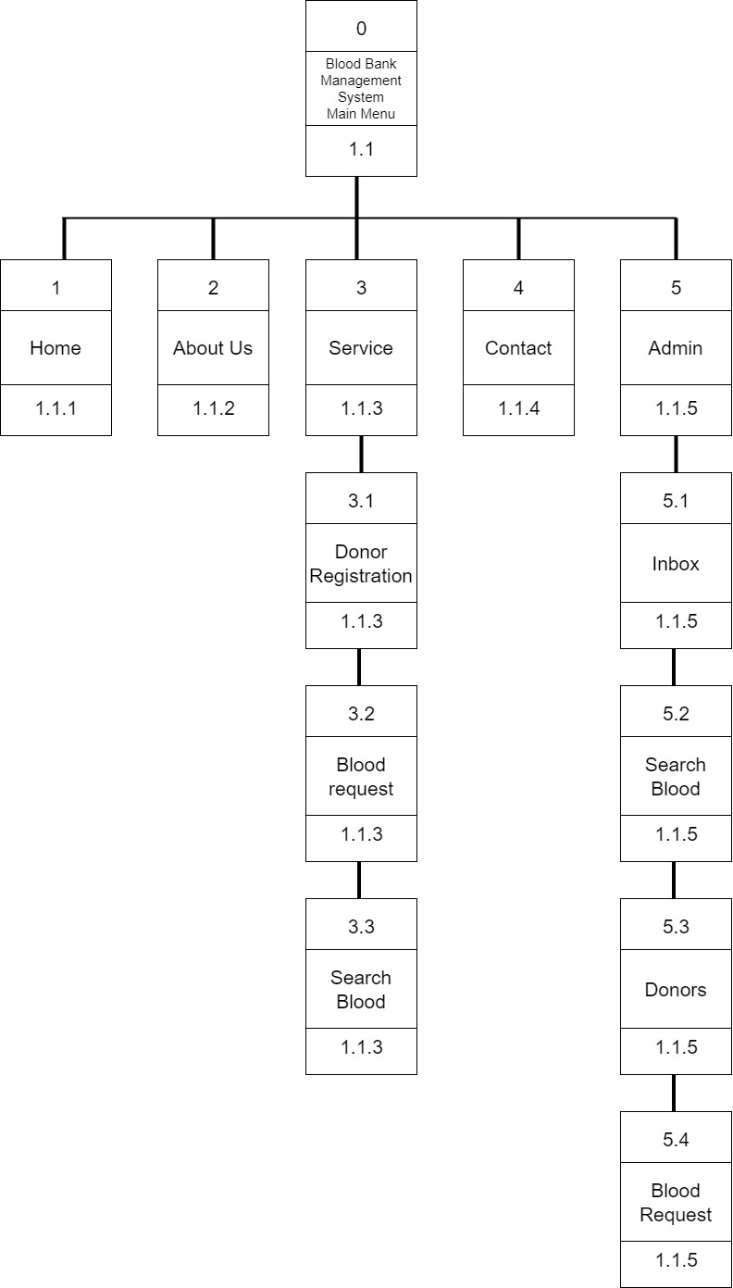

**Figure 3. 8 Interface Design of Blood Bank Management System**

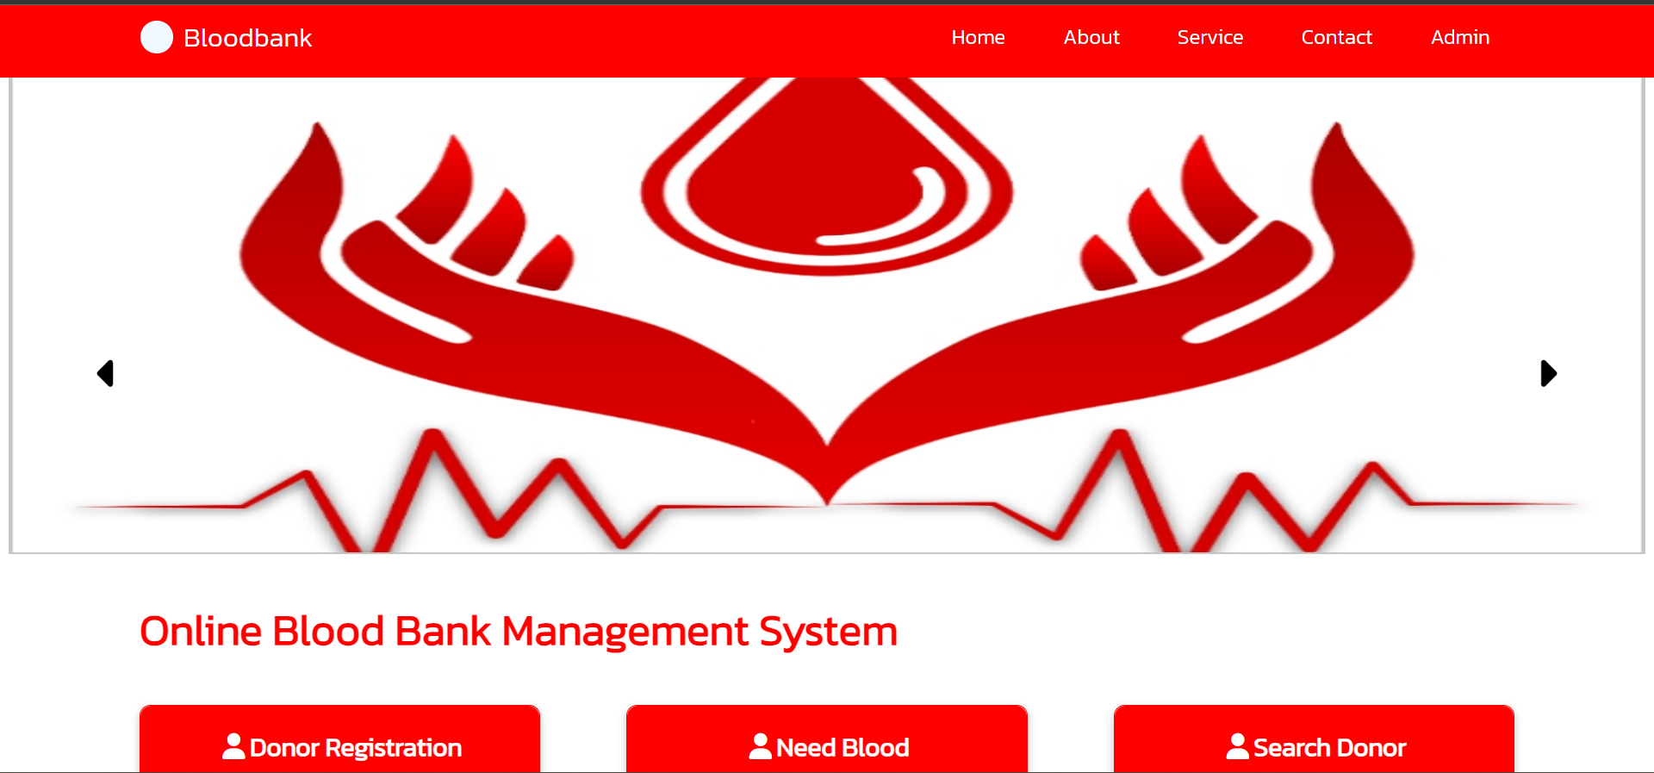

**Figure 3. 9 UI Interface of Blood Bank Management System**

### **3.2.4 Physical DFD**

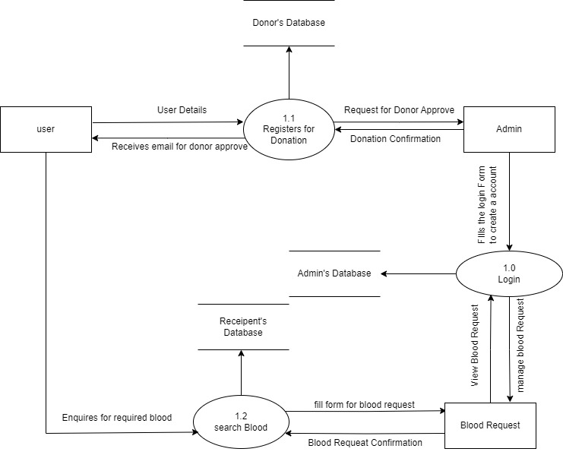

**Figure 3. 10 Physical Diagram of Blood Bank Management System**

A physical data store that stores all the information related to blood donors, such as donor details, contact information in blood donor database. A blood inventory database stores and maintains the inventory of blood units, including information about blood types, quantities available. Login database stores the information about system administrators, including usernames, and administrative privileges.

# **CHAPTER 4**

# **IMPLEMENTATION AND TESTING**

## **4.1 Implementation**

### **4.1.1 Tools Used (CASE tools, Programming Languages, Database Platforms)**

The mostly used tools used in this application are HTML, CSS, JavaScript, jQuery, PHP, MySQL.

#### **4.1.1.1 Front End Tools**

**HTML:** HTML is the standard markup language that is used to design the structure and content of this application. This tool has been used in the project for displaying text, images, and other form of multimedia on the webpage.

**CSS:** CSS is used in this page to provide the visual style to the pages. It has been used in this project to create a consistent look which can improve user experience. It used to control the layout, font, color and visualize the aspect of project.

**JavaScript:** JavaScript web framework is one of the best ways to stack backend and frontend frameworks and has been used for the same in the project. It has been used for adding interactivity to the user interface, validate user input and perform calculations in this project.

#### **4.1.1.2 Backend Tools**

**PHP:** It is a server-side scripting language that is used to create a dynamic web page which can interact with databases. It has been useful to handle the server-side processing of data, such as storing and retrieving data from the database like MySQL.

**MySQL:** MySQL is an open-source relational database management system (RDBMS). It is used MySQL to store and manage data related to blood donors, recipients and inventory. It has been used in this project to perform operations like data insertion, deletion, and modification.

### **4.1.2 Implementation Details of Modules (Description of Procedures/ functions)**

There are different modules descriptions. They are described below:

**Patient’s Module:** This module is dedicated to search for blood required anytime, anywhere online without any registration.

**Admin Module:** This module can be accessed by those who have admin credentials and are responsible for processing the donation request and blood necessity request.

**Donor Management Module:** This module is designed to implement a user-friendly interface for donor registration and profile management. They can fix their time to donate blood when they want to unless it’s an emergency for the blood requests.

**Inventory Management Module:** this module is designed for a database schema to store and track blood inventory details such as blood type, quantities. It implements a real-time monitoring of inventory levels to ensure sufficient stock and avoid shortages.

## **4.2 Testing**

Testing is the process of detecting the errors. It performs a very crucial role for quality assurance and for ensuring the reliability of the software. The results of testing are used later on during maintenance also. Testing requires a lot of time and labor.

### **4.2.1 Unit Testing**

Unit testing is a software development process in which the smallest testable parts of an application, called units, are individually and independently scrutinized for proper operation. Blood Bank Management System contains different types of individual parts that are tested. Some of the test cases are:

**Table 4. 1 Donor Registration**

|  |  |  |  |  |  |
| --- | --- | --- | --- | --- | --- |
| S. N | Action | Input | Expected Outcomes | Actual Outcomes | Test Result |
| 1 | Launch application | http://localhost/Blood_Bank_project/Client/donor.php | Donor Registration Page | Donor Registration Page | Pass |
| 2 | Submit without any details | Null | Form Must be filled | Please fill the form | Pass |
| 3 | Enter numeric name | Full Name: 123 Shrestha  Gender: Male  Blood Group: O+  Address: Kathmandu  Email: [abc123@gmail.com](mailto:abc123@gmail.com)  Phone No.1: 1234567890  Birthdate: 2002-02-01  New Donor: yes | Invalid Name format | Name must contain characters only | Pass |
| 4 | Enter Alphabets in contact detail | Full Name: Sita Shrestha  Gender: Female  Blood Group: O+  Address: Kathmandu  Email: [sita123@gmail.com](mailto:sita123@gmail.com)  Phone No.1: abcd  Birthdate: 2000-06-06  New Donor: yes | Invalid Contact Details | Contacts should only contain numbers | Pass |
| 5 | Enter correct details | Full Name: Sita Shrestha  Gender: Female  Blood Group: AB+  Address: Nayabazar  Email: [sitashrestha1883@gmail.com](mailto:sitashrestha1883@gmail.com)  Phone: 2343343434  Birthdate: 2000-05-02  New Donor: yes | Sends email in the email id provided by the user. | Donor Registration successful email sent. | Pass |

**Table 4. 2 Request Blood**

|  |  |  |  |  |  |
| --- | --- | --- | --- | --- | --- |
| S. N | Action | Input | Expected Outcomes | Actual Outcomes | Test Result |
| 1 | Launch application | http://localhost/Blood_Bank_project/Client/requestblood.php | Need blood Page | Need blood Page | Pass |
| 2 | Submit without any details | Null | Form Must be filled | Please fill the form | Pass |
| 3 | Enter numeric name | Patient Name: 123  Required Blood: A+  Gender: Male  Need unit of blood: 2  Hospital name and address: abc, nayabazar  Reason for blood: Accident  City: Kathmandu  When Required: 2023-07-21  Contact Name: Tajo  Email id: ABC@gmail.com  Phone no.: 9808105602 | Invalid Name format | Name must contain characters only | Pass |
| 4 | Enter Alphabets in contact details | Patient Name: Anju  Required Blood: A-  Gender: Female  Need unit of blood: 2  Hospital name and address: XYZ, Balaju  Reason for blood: Operation  City: Kathmandu  When Required: 2023-07-22  Contact Name: rapun  Email id: xyz@gmail.com  Phone no.: 9863132434 | Invalid Contact Details | Contacts should only contain numbers | Pass |
| 5 | Enter correct details | Patient Name: Rita Riwaj  Required Blood: O+  Gender: Female  Need unit of blood: 3  Hospital name and address: Model, baneswor  Reason for blood: operation  City: Kathmandu  When Required: 2023-07-22  Contact Name: Dhiraj Riwaj  Email id: [sitashrestha1883@gmail.com](mailto:sitashrestha1883@gmail.com)  Phone no.: 9876564564 | Sends email saying blood requested in the email id provided by the user. | Request for blood successful and thank you email sent to the respective email id. | Pass |

**Table 4. 3 Search Blood details**

|  |  |  |  |  |  |
| --- | --- | --- | --- | --- | --- |
| S. N | Action | Input | Expected Outcomes | Actual Outcomes | Test Result |
| 1 | Launch application | http://localhost/Blood_Bank_project/Client/searchblood.php | Search blood details Page | Search blood details Page | Pass |
| 2 | Search without any blood group | Null | Enter the blood group | Please fill the blood group | Pass |
| 3 | Enter a blood group not available in blood bank | A- | Blood group not available and not able to request for blood | Cannot request for blood | Pass |
| 4 | Enter correct blood group | AB+ | Blood group data of AB+ | Shows all the AB+ blood Group in inventory | Pass |

### **4.2.2 System testing**

System testing is an overall testing of the system after integrating all the functions of the project. When all the functions of the Blood Bank Management System are done.

**Table 4. 4 User Interface**

|  |  |  |  |  |  |
| --- | --- | --- | --- | --- | --- |
| S. N | Action | Input | Expected Outcomes | Actual Outcomes | Test Result |
| 1 | Launch application | http://localhost/Blood_Bank_project/signup/signup.php | Directed to sign in page | Directed to sign in page | Pass |
| 2 | Sign up new account | Name: Sita Shrestha  Phone No.: 9808105602  Email: [sitashrestha1883@gmail.com](mailto:sitashrestha1883@gmail.com)  Username: Sita stha  Password: Sita1234@ | Sign in successful | Sign in successful | Pass |
| 3 | Login by same user | Username: Sita stha  Password: Sita1234@ | Logged in successfully | Logged in successfully and lead to dashboard | Pass |
| 4 | Search blood | Blood Group: A+ | Blood group found in inventory | Found the related blood | Pass |

**Table 4. 5 Admin Interface**

|  |  |  |  |  |  |
| --- | --- | --- | --- | --- | --- |
| S. N | Action | Input | Expected Outcomes | Actual Outcomes | Test Result |
| 1 | Launch application | http://localhost/Blood_Bank_project/signup/signup.php | Directed to sign in page | Directed to sign in page | Pass |
| 2 | Sign up as admin | Name: Super Admin  Phone No.: 2147483647  Email: abcgamming123@gmail.com  Username: admin  Password: Admin123@ | Signed in as admin | Sign in successfully | Pass |
| 2 | Admin Login with same username and password | Username: Admin  Password: Admin123@ | Login successful | Login successful | Pass |
| 3 | Manage blood requests | Take action to pending blood request admin | Redirected to pending blood request page | Redirected to pending blood request page | Pass |
| 4 | Manage donor status | Manage non-active donors | Redirected to non-active donor page | Redirected to non-active donor page | Pass |
| 5 | Manage Blood Requests | View blood requests | Redirect to blood request page | Redirected to blood request page | Pass |
| 6 | Manage users | View total of users in the application | Redirect to total user page | Redirect to total users’ page and see total of users | Pass |

# **CHAPTER** **5**

# **CONCLUSION AND FUTURE RECOMMENDATIONS**

## **5.1 Lesson learnt/ Outcome**

While in the process of developing this application, there were many instances where the author felt like something more could be added but due to the lack of enhancement and excellence in the programming languages there might be some loopholes that could be fixed once the authors get to learn and explore this technology more and more. As this project and everything was new to adopt, the authors learned about time management as the authors had the deadline to submit the project with the documentation.

Even though this whole project turned out to be exactly what the authors expected it to be, there are some functions that the authors would like to modify in the forthcoming days and make it more user-friendly and competitive.

## **5.2 Conclusion**

In conclusion, the design of a blood bank management system's database schema plays a crucial role in efficiently managing and organizing information related to blood donors, blood units, recipients, and donations. The schema presented above provides a foundation for storing and retrieving data in a structured manner.

By employing this schema, the blood bank can effectively track and manage donors, including their personal details, contact information, and donation history. The system also maintains information about different blood groups and their availability, ensuring efficient matching between donors and recipients based on compatibility.

The database schema incorporates relationships between entities, such as the association of blood units with specific blood groups and donors, and the link between donations and donors/units. These relationships enable the system to provide accurate and reliable information, supporting various operations, such as blood unit reservation.

However, it is important to note that the provided schema serves as a starting point and may require customization based on the specific needs of the blood bank. Additional tables and attributes can be added to accommodate more complex functionalities or reporting requirements.

Overall, the database schema presented in this report lays the foundation for a robust and efficient blood bank management system, enabling streamlined operations, effective donor-recipient matching, and accurate tracking of blood units and donations. With proper implementation and customization, this schema can contribute to the success of a blood bank in serving the community and saving lives through efficient blood management.

## **5.3 Future Recommendation**

This may be taken into greater element and greater paintings may be accomplished to convey extra capabilities. Further paintings may be accomplished that allows you to boost the efficiency of the device. Google map can be used to track the vicinity of both donor and patient as it presents the exact statistics approximately geographical regions and websites across the world. Adding the user/donor login to view for lag investigation report for the blood they donated.

1. **Usability and User Experience Enhancements:** Continuously improve the user interface and experience based on user feedback. The system should be intuitive, easy to navigate, and responsive.
2. **Mobile Blood Donation Apps:** Develop mobile apps that allow donors to schedule appointments, receive notifications about blood donation drives, and access their donation history. This can improve donor engagement and participation.
3. **Emergency Response Integration:** Integrate the system with emergency response agencies to ensure timely blood availability during disasters and mass casualty events.

# **REFERENCES**

1. S.Mufaqih; Abiyyu Fawaaz Kanz; S.ramadhan, Afajar (2020) “Blood Bank Information System based on Cloud in Indonesia” Information Systems Management Department, BINUS Graduate Program – Master of Information Systems Management, Universitas Bina Nusantara, Jakarta, Indonesia
2. “Social Challenges and Opportunities in Blood Bank distribution In India” by Dhiviya Rose (2020) School of Computer Science, University of Petroleum and Energy Studies, Bidholi Campus, Dehardun, India
3. “Modeling and Analysis Of Distribution of Blood Stock to Healthcare Units” by [Pratiksha Patil](https://www.semanticscholar.org/author/Pratiksha-Patil/2057401088);  [P. Ray](https://www.semanticscholar.org/author/P.-Ray/1956556);  [Esha Saha](https://www.semanticscholar.org/author/Esha-Saha/15811905) (2018) In book: Healthcare Systems Management: Methodologies and Applications
4. “IOT Based Blood Bank Maintains System” by Dr. Shilpa P. Kodgire; Soni Gaikwad; Kiran Khandagle 2022, Journal of Embedded Systems and Processing
5. “Online Blood Bank Management System” by Mohd Saif Abbas; Sheenu Rizvi 2022, Journal of Management and Service Science (JMSS)

# **APPENDIX**

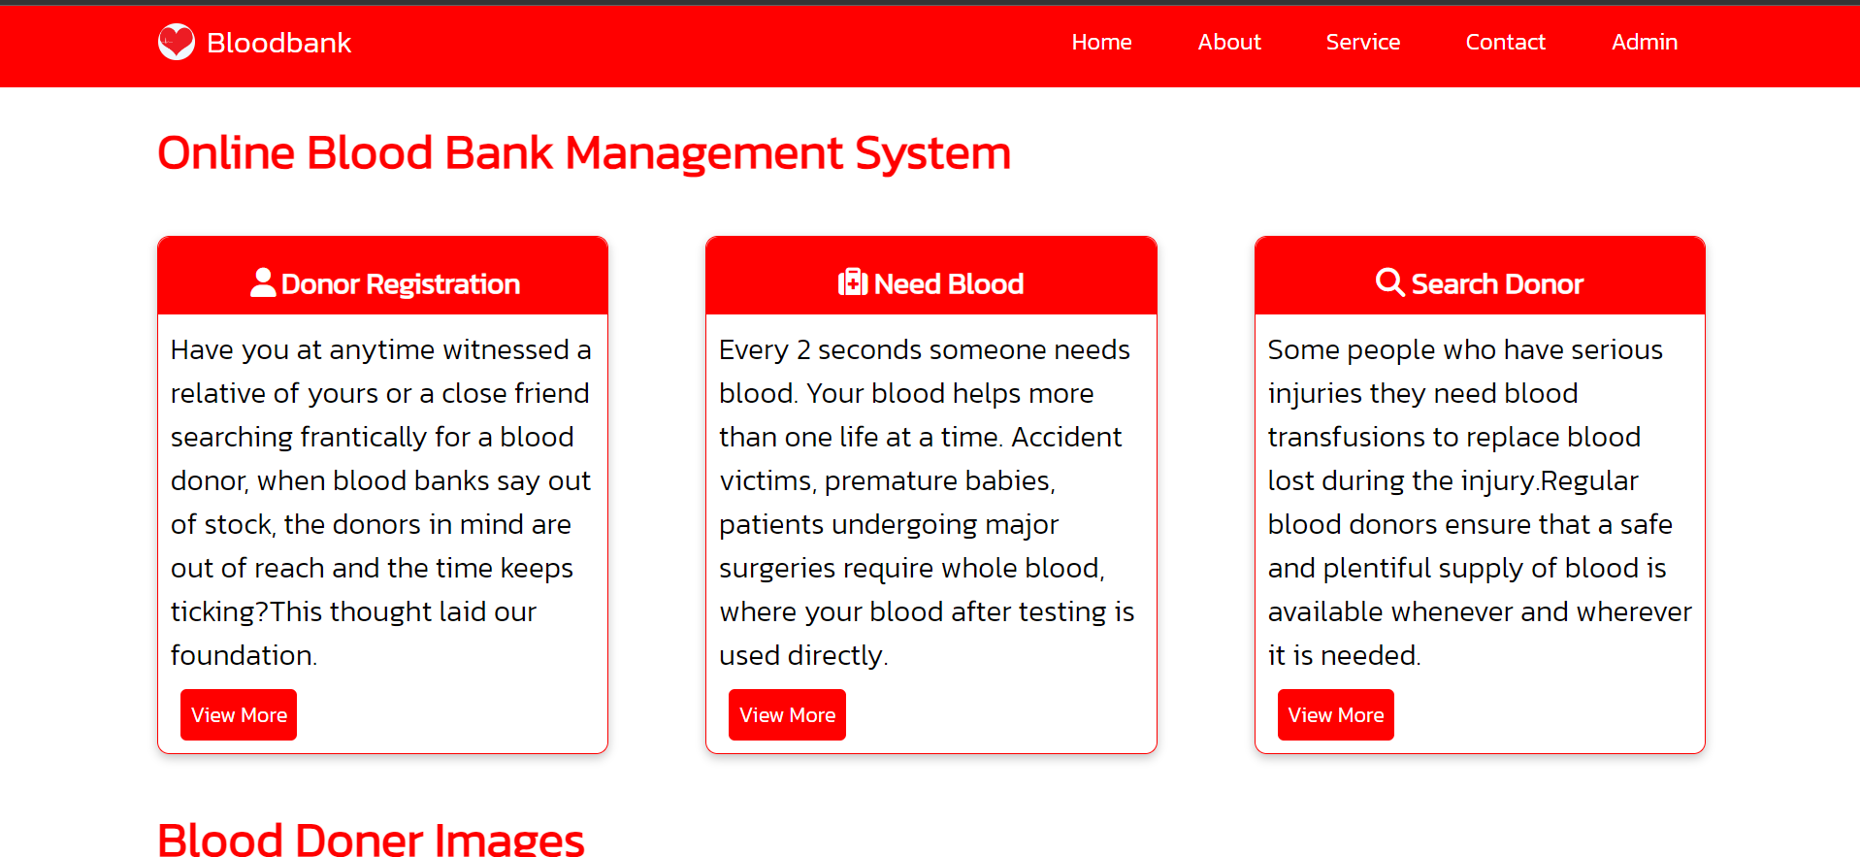

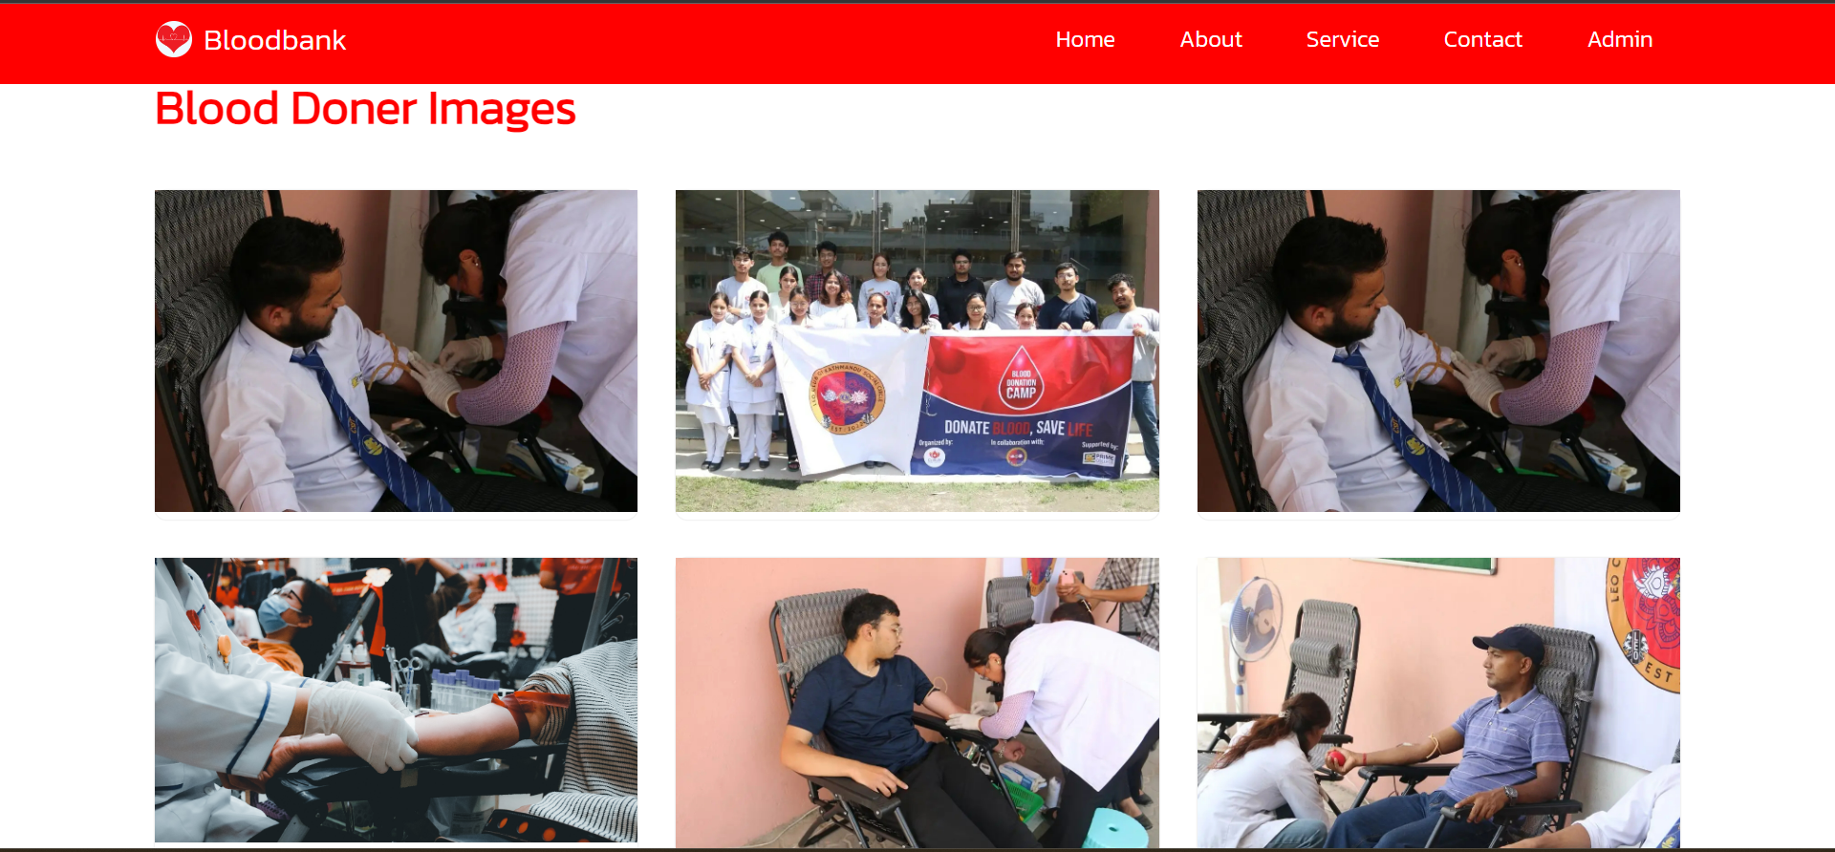

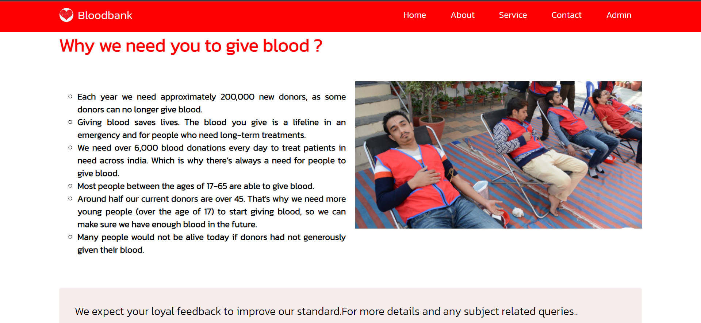

Homepage

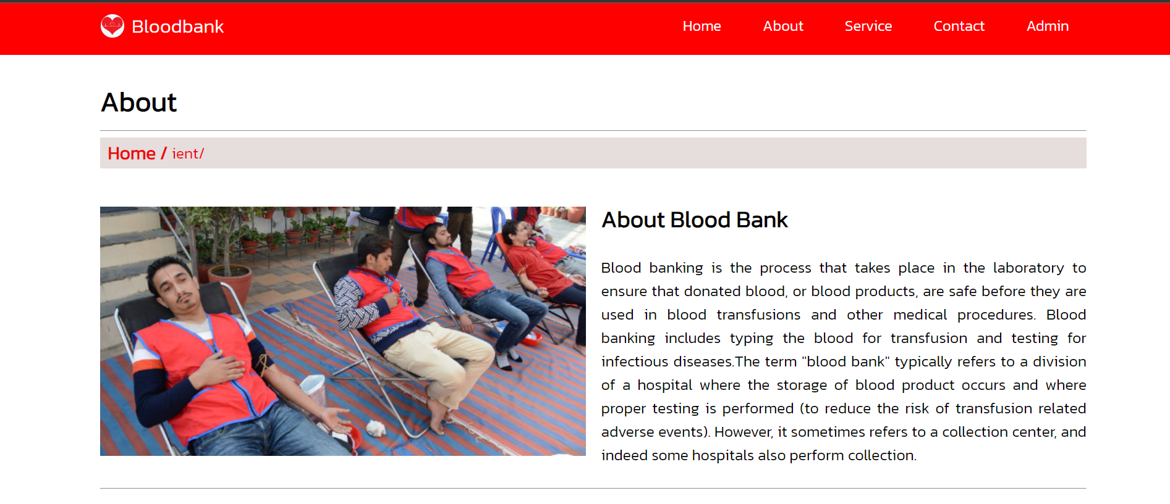

About Us

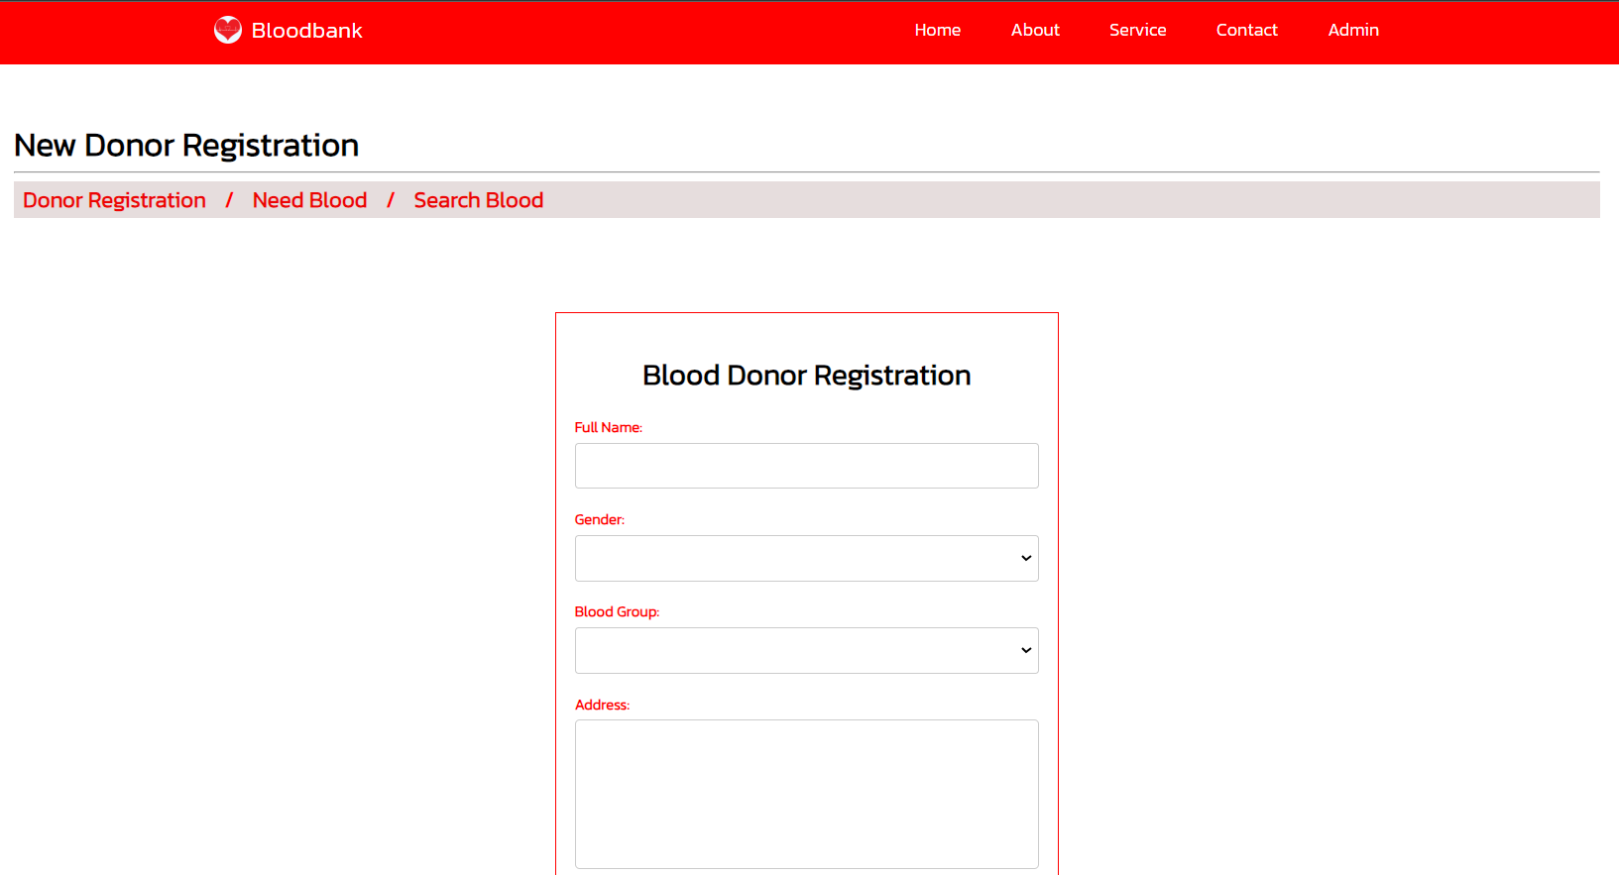

Services

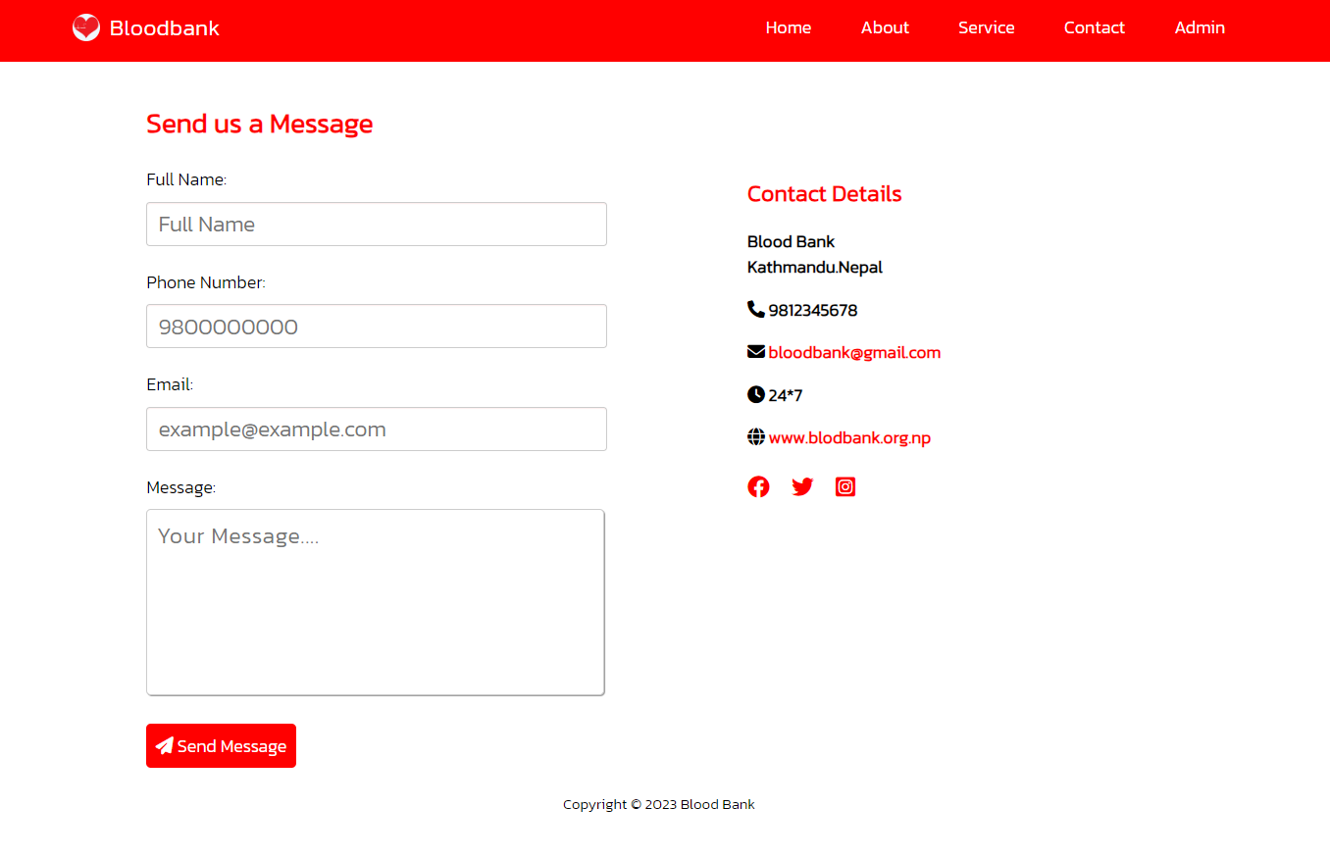

Contact us

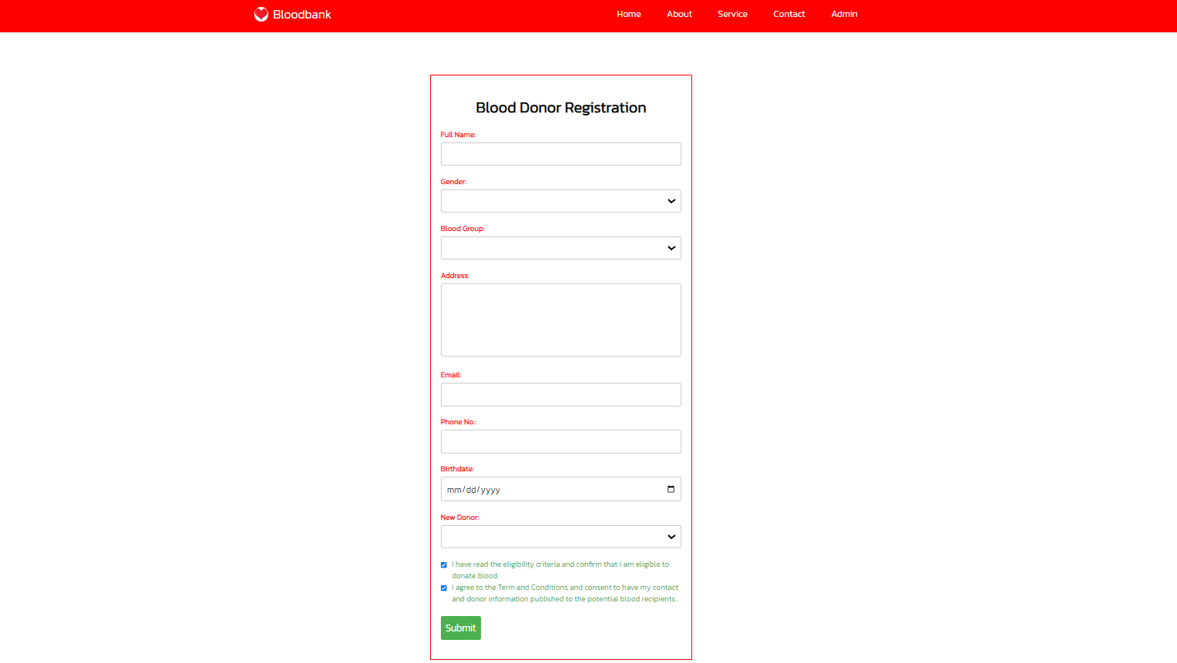

Donor Registration Page

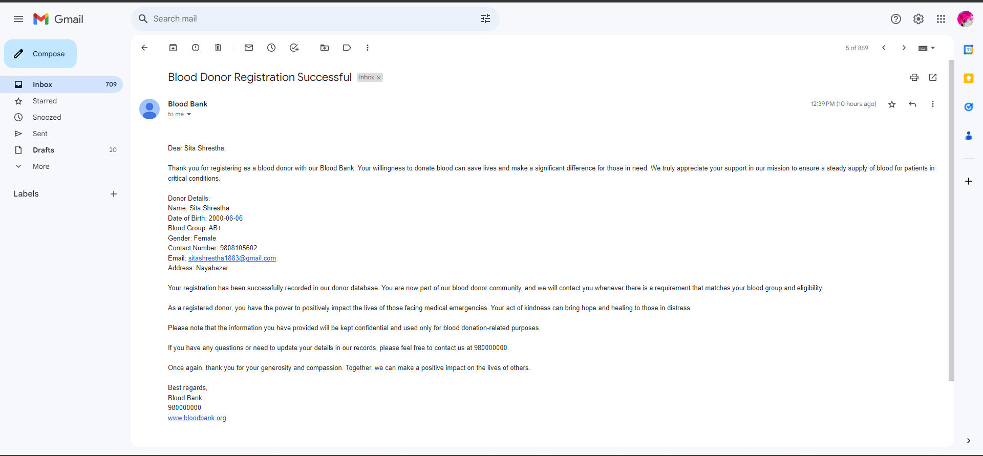

Blood Donor Registration Successful Email

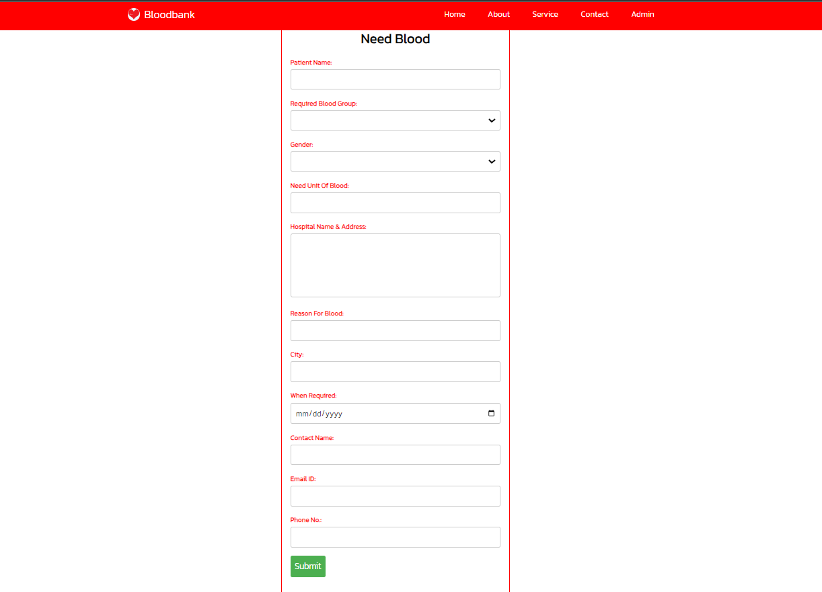

Blood Request Page

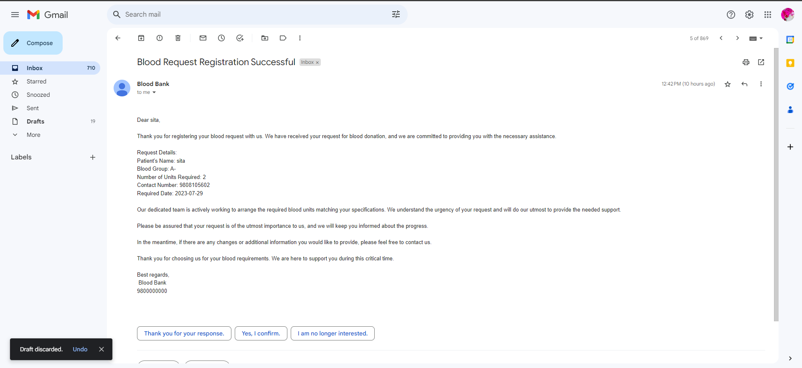

Blood Request Successful Email

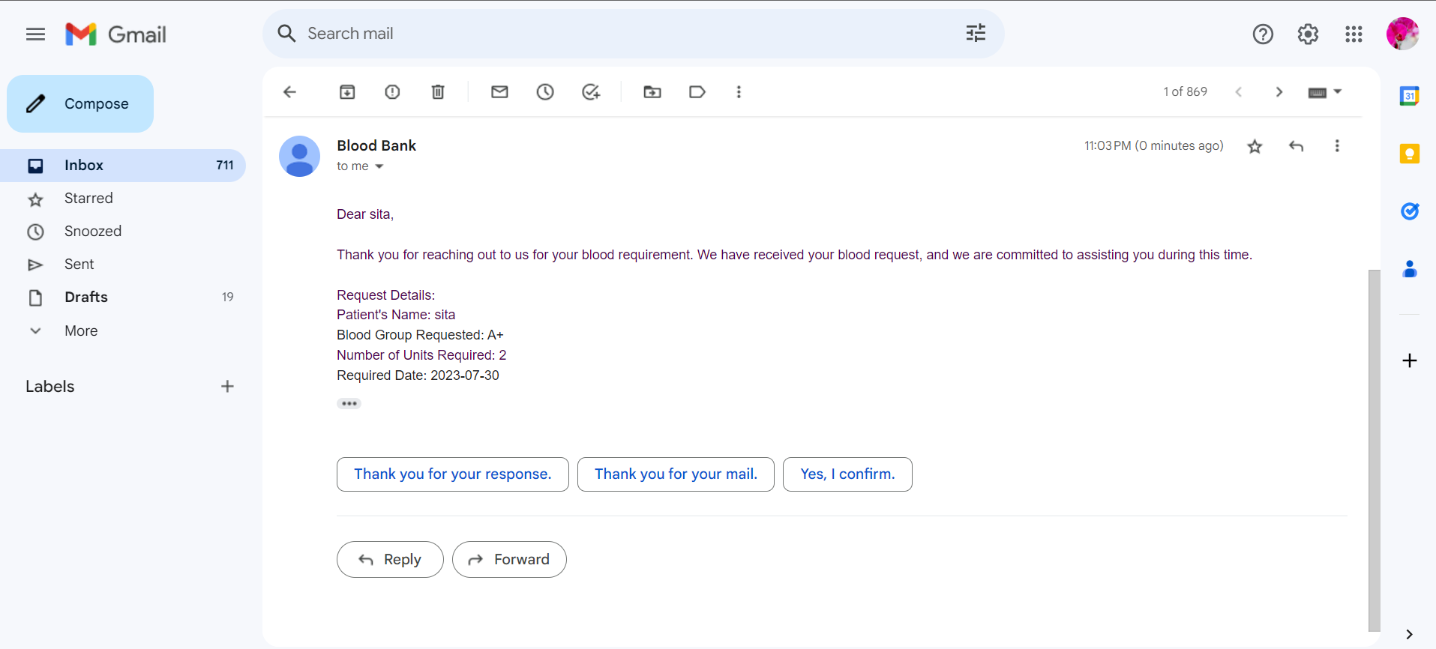

Blood Request Approved by Admin Email

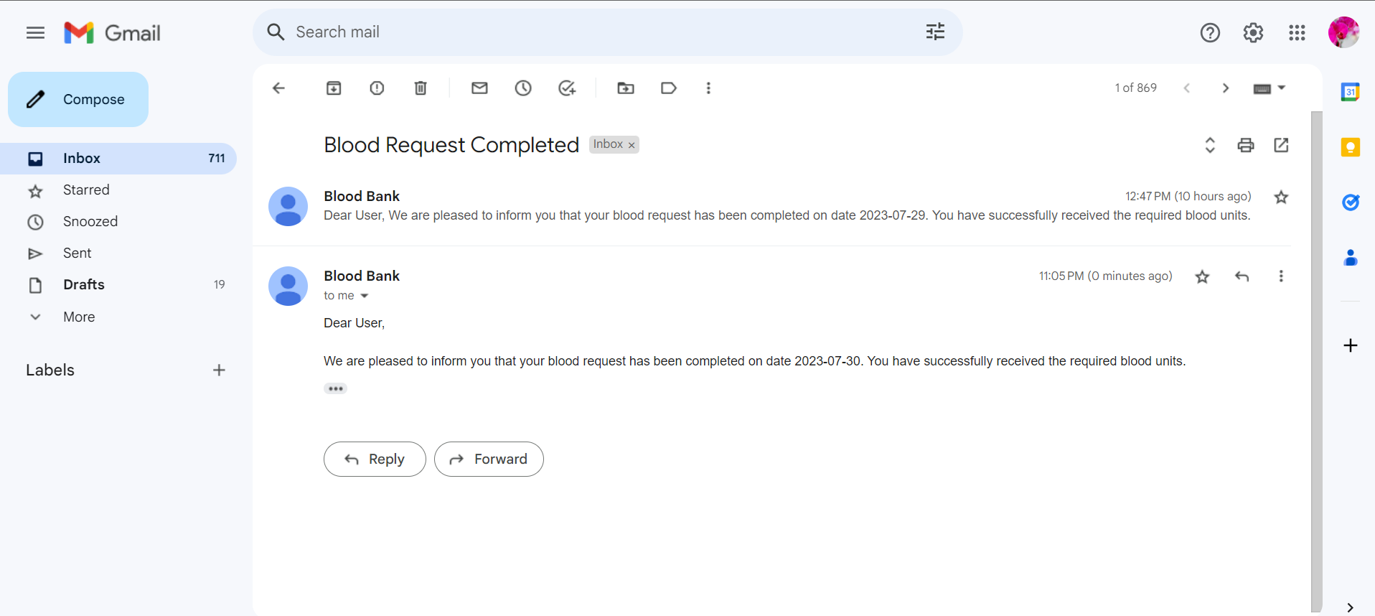

Blood Request Completed Email

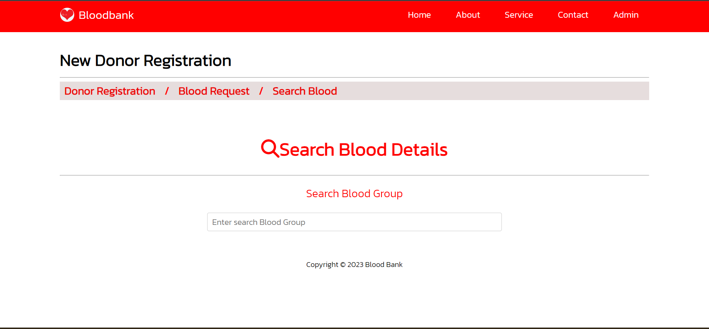

Search Blood Page

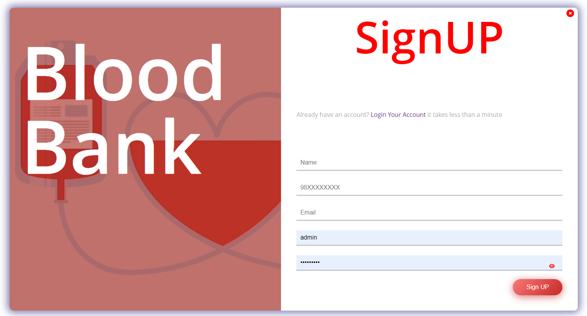

Sign up page

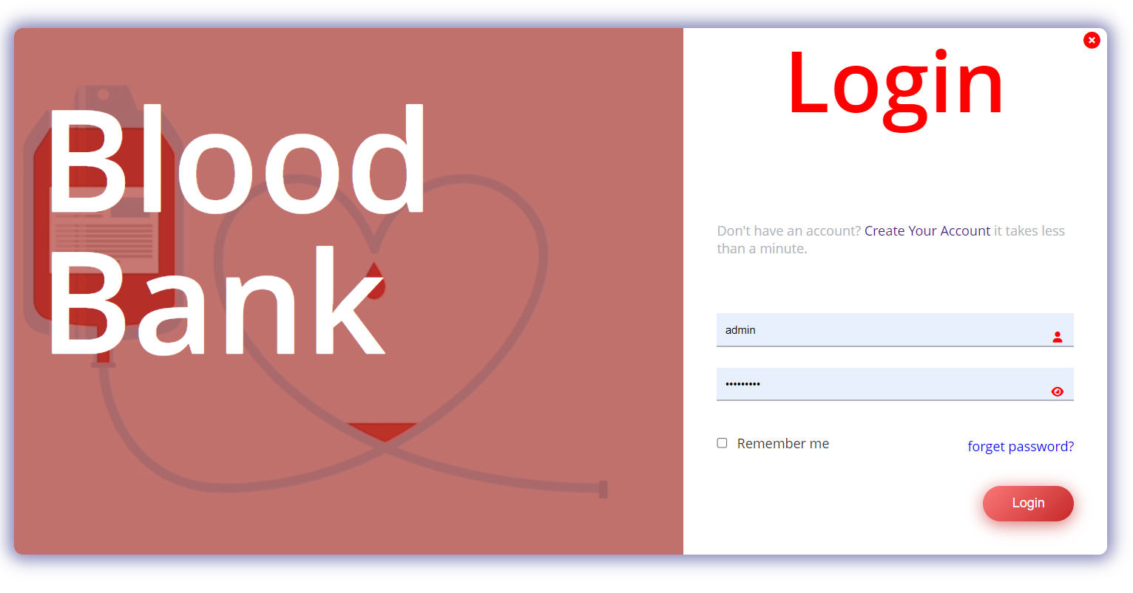

Login In Page

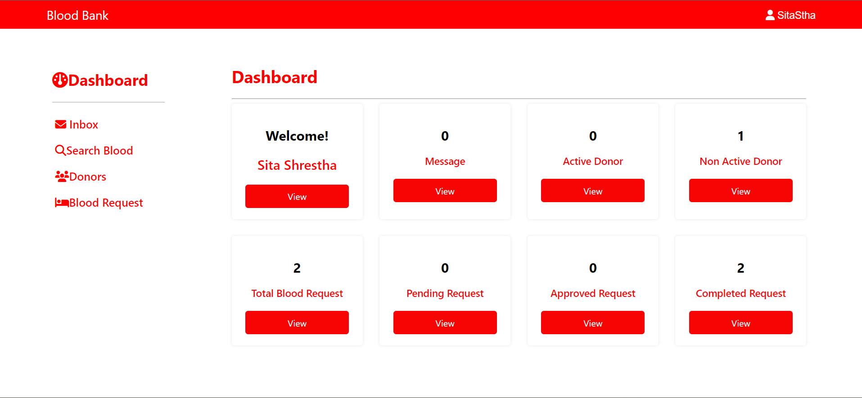

User Dashboard

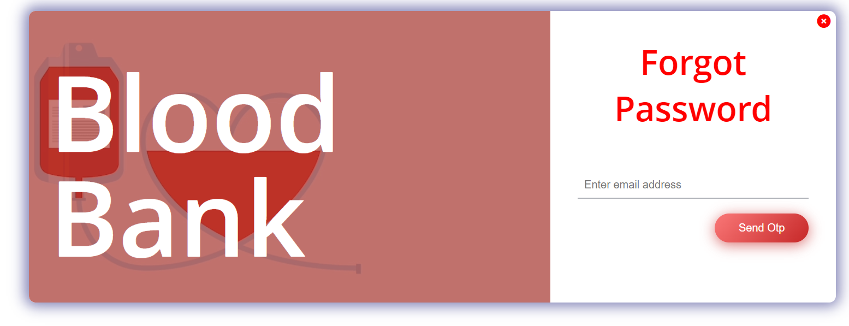

Forget Password Page

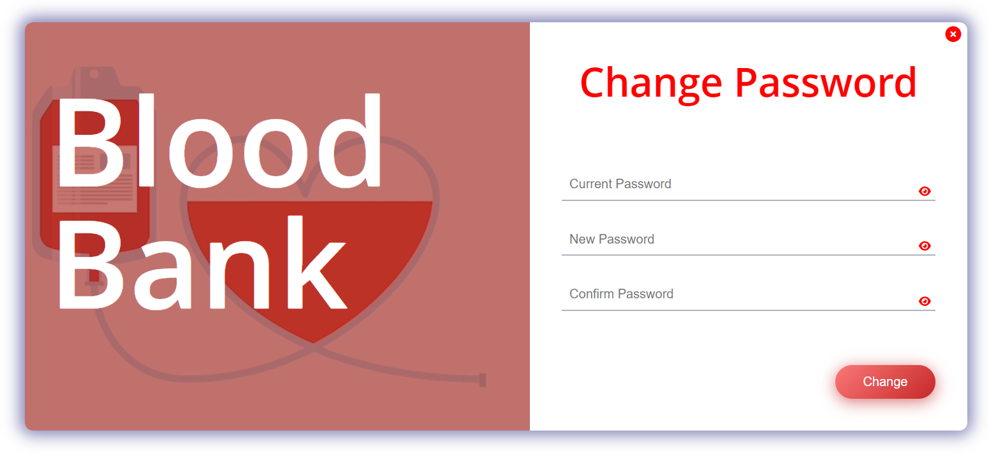

Change Password

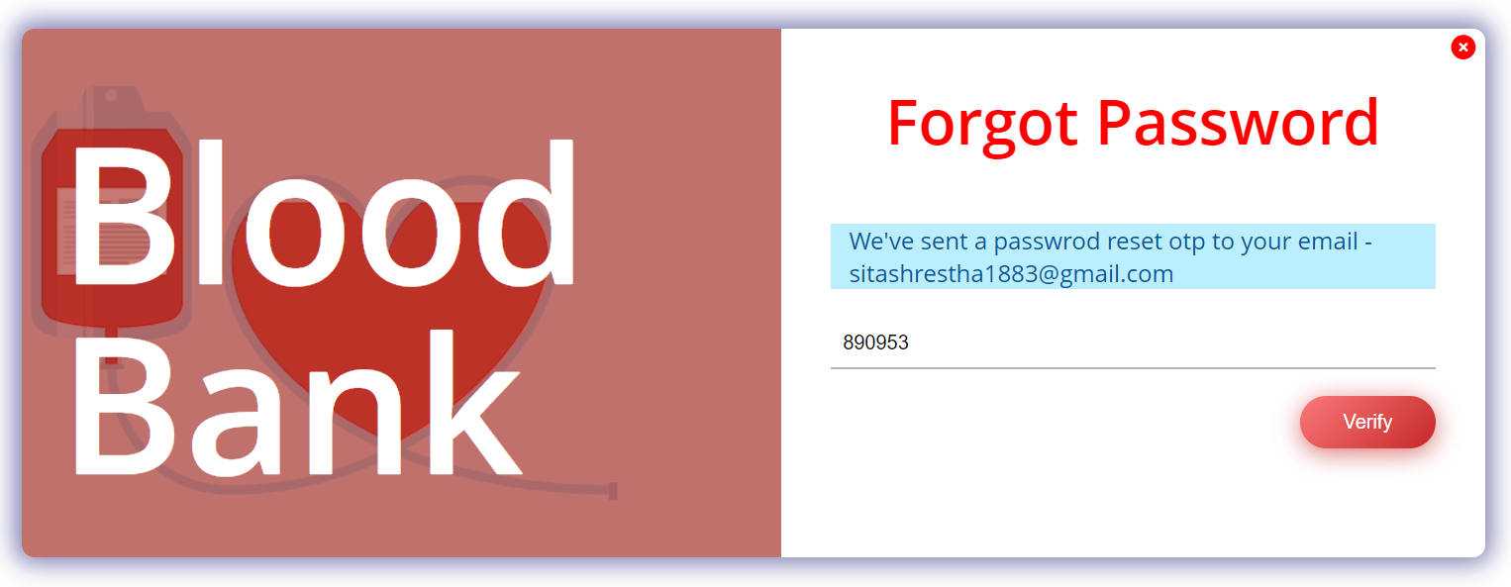

Received an OTP Code

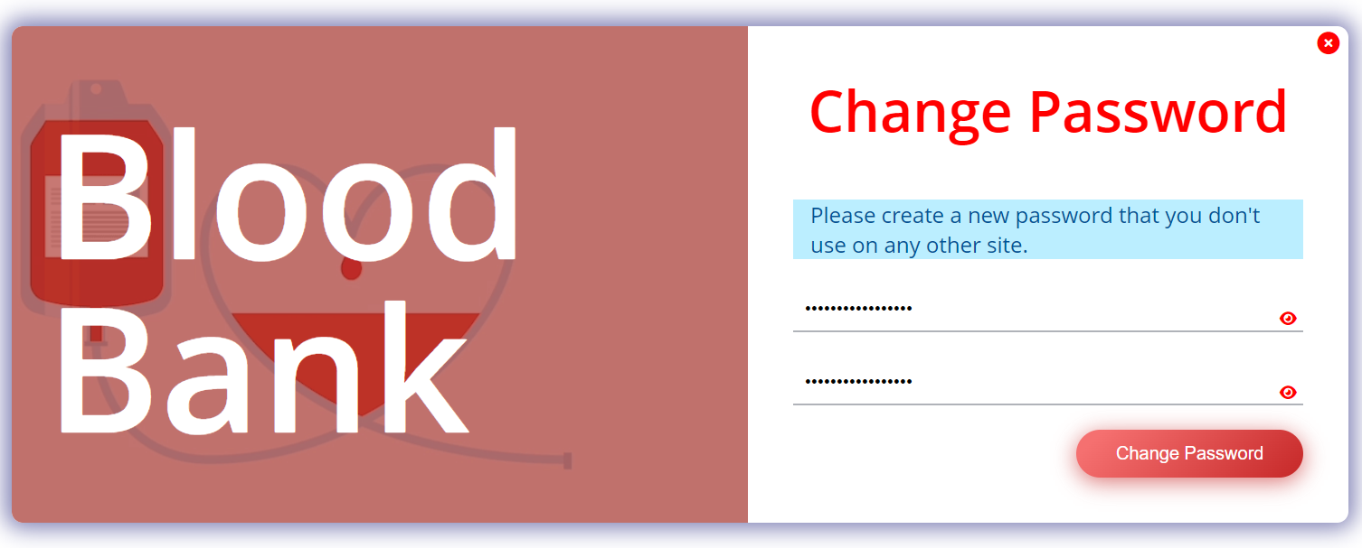

After Verifying the OTP Code

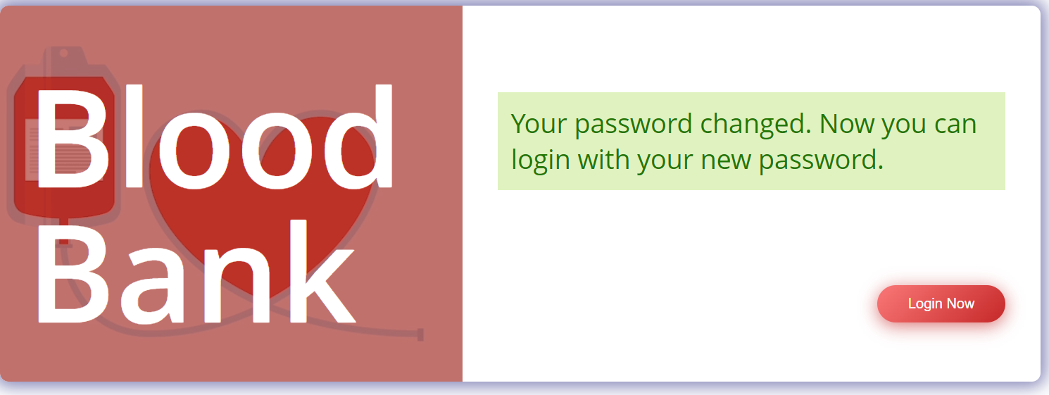

Password Changed Successfully

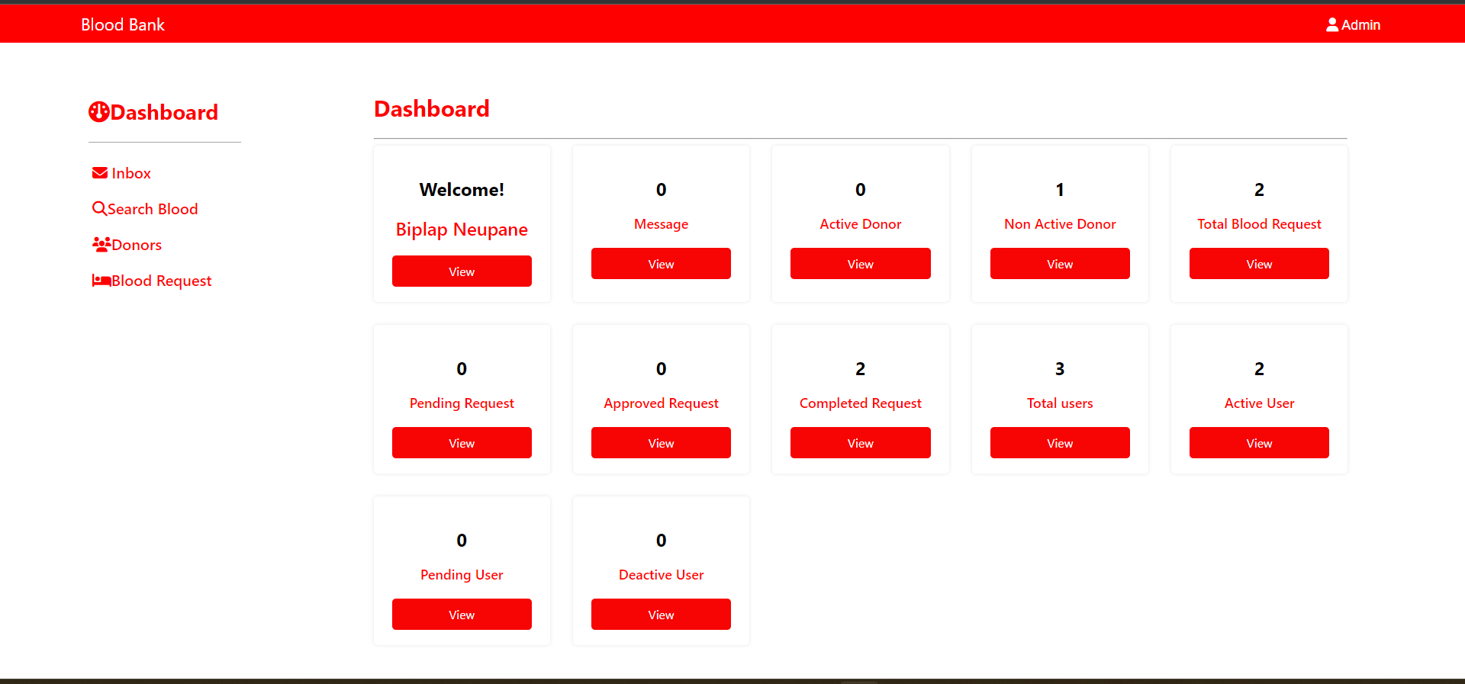

Admin Dashboard

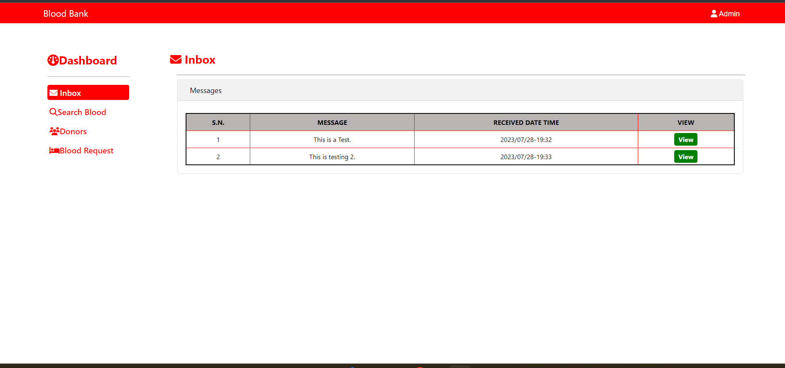

Admin Inbox

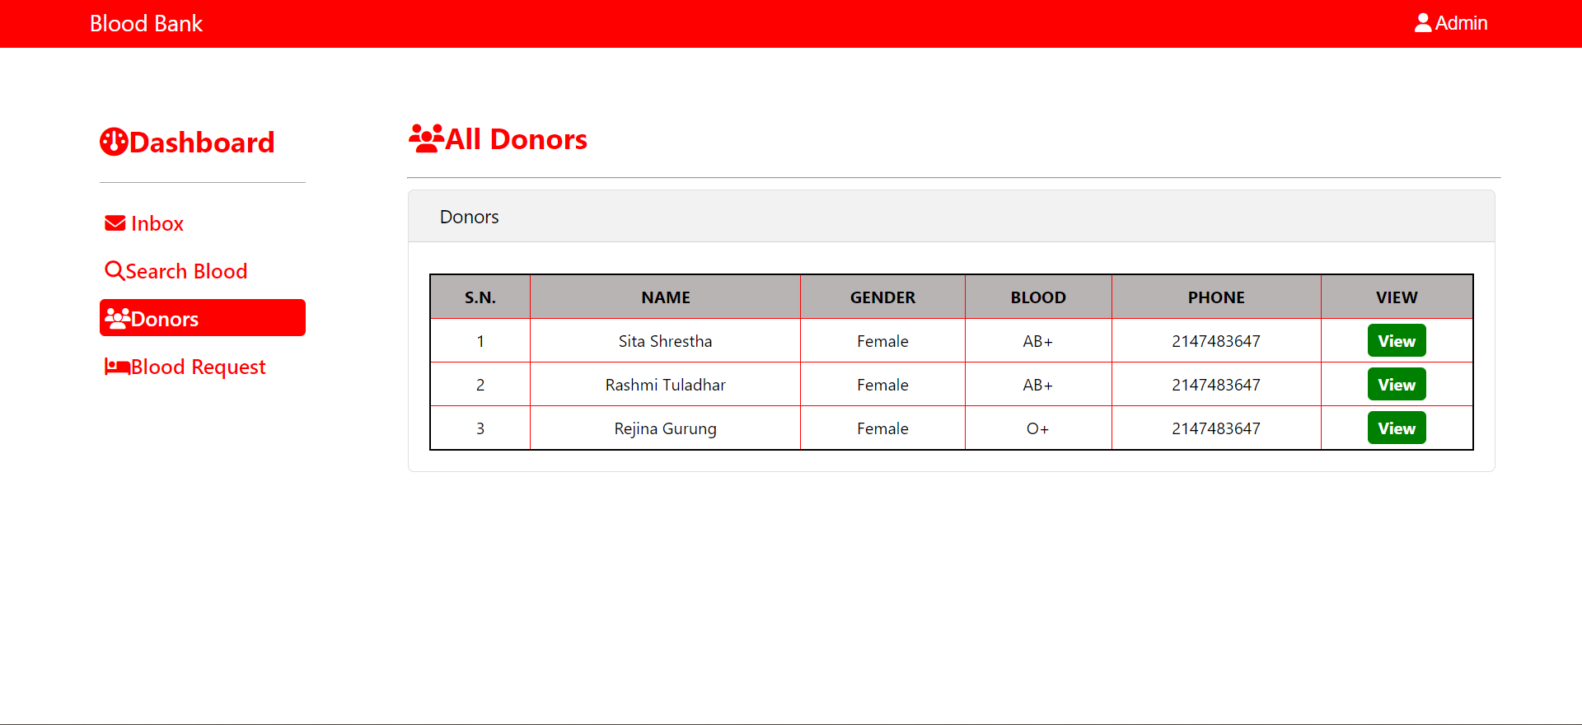

Total Donors

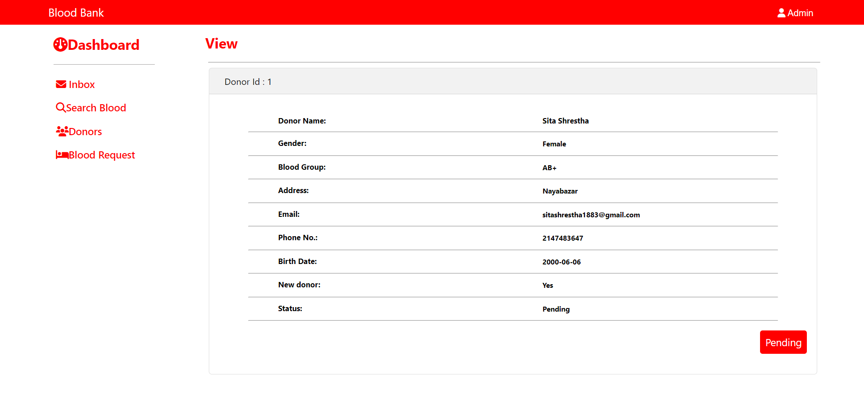

Donor id View

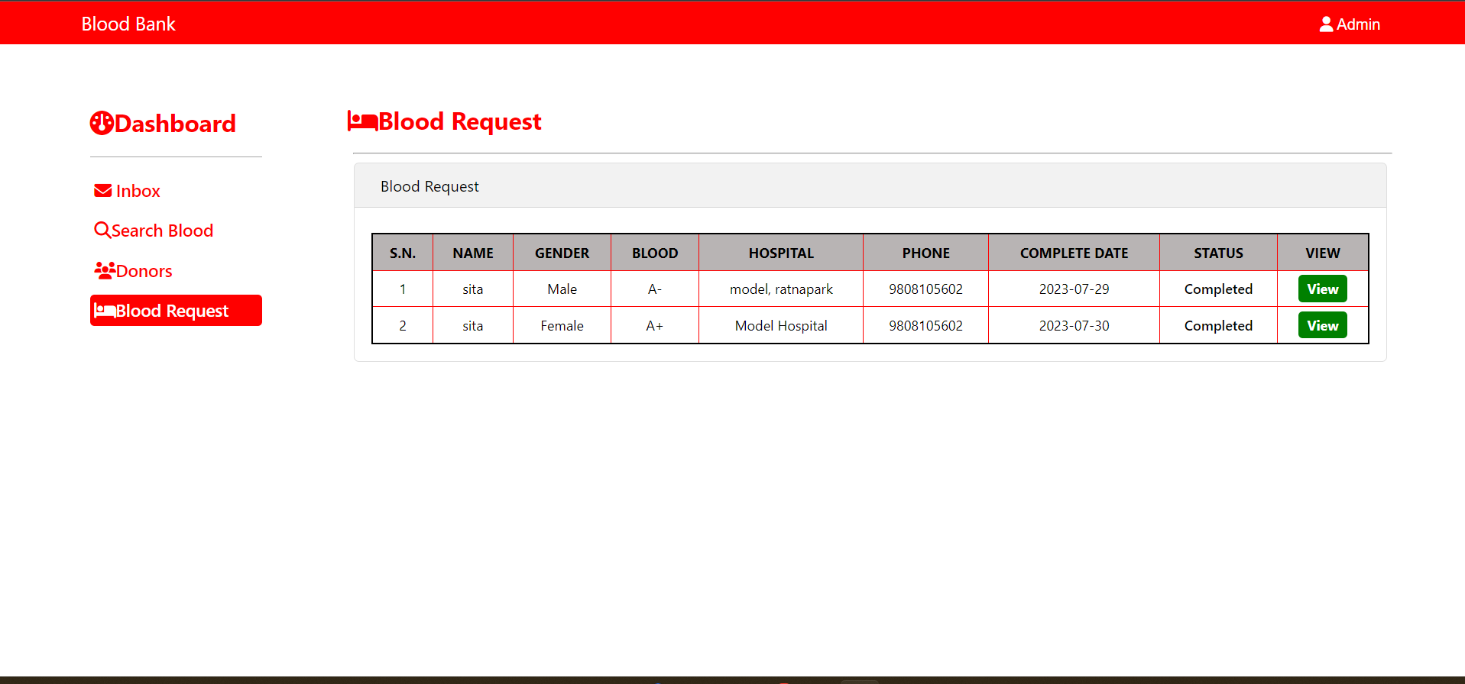

Blood Request view

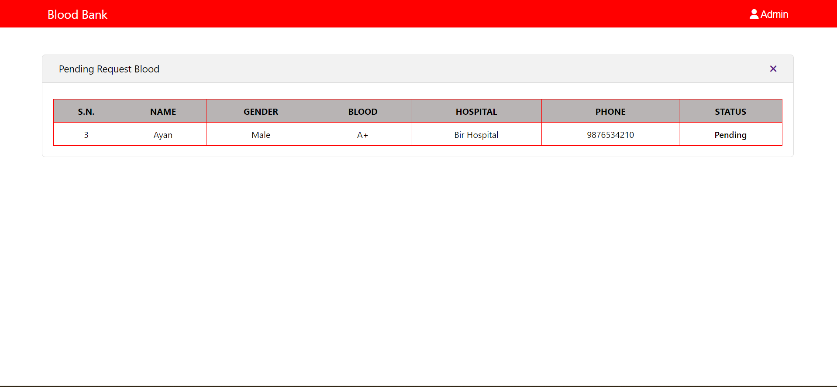

Pending Blood Requests

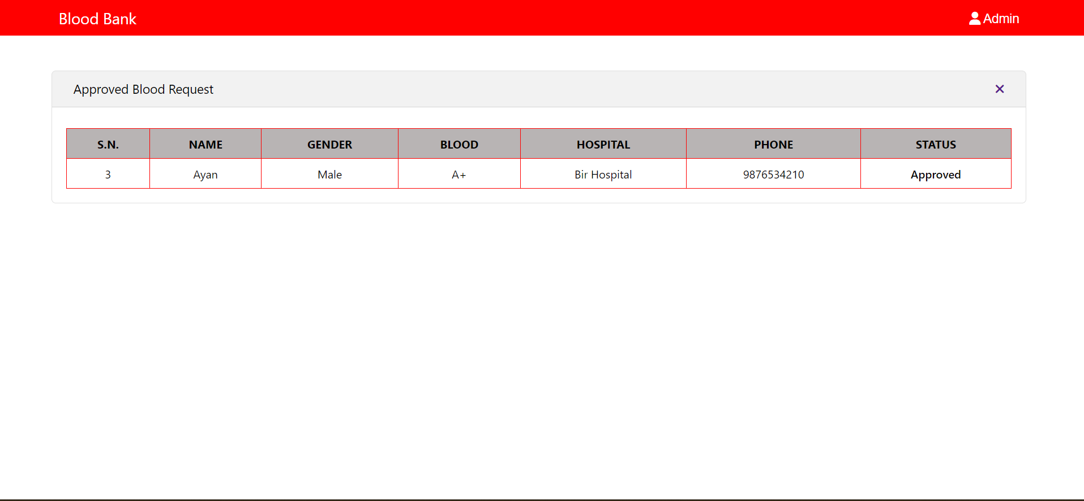

Approved Blood Requests

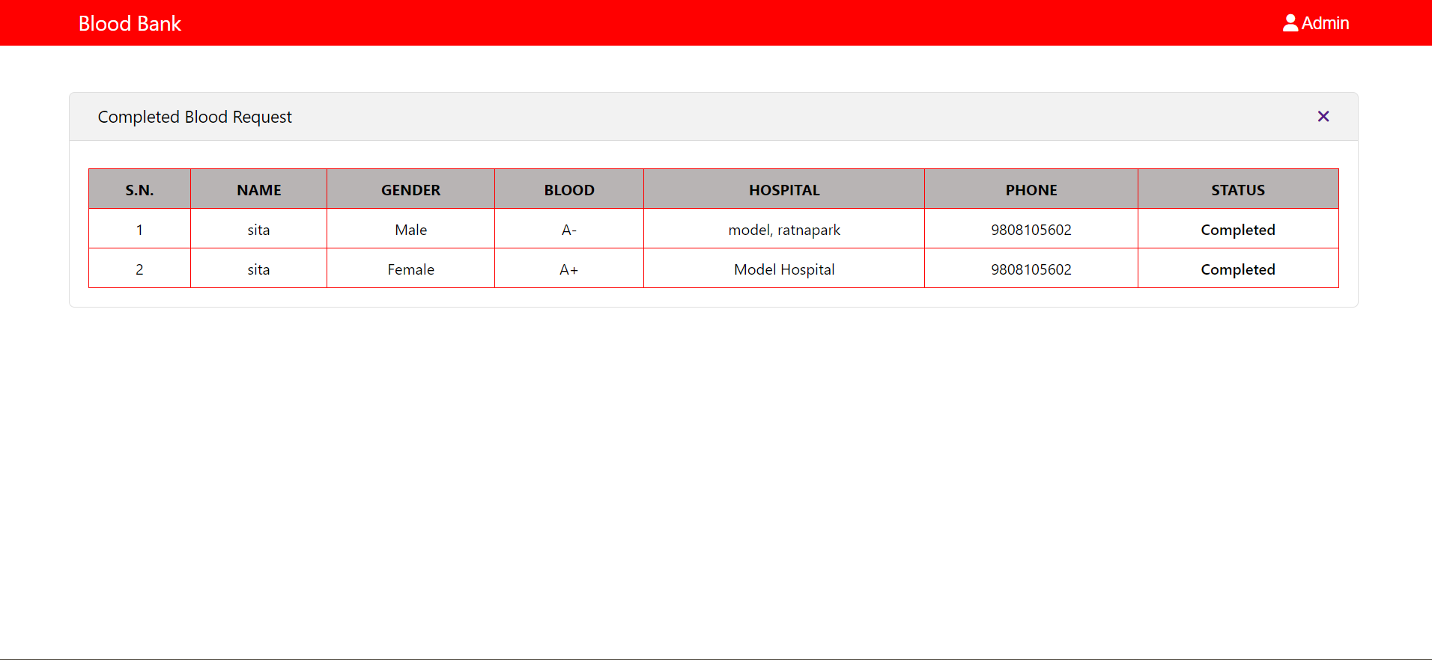

Completed Blood Request

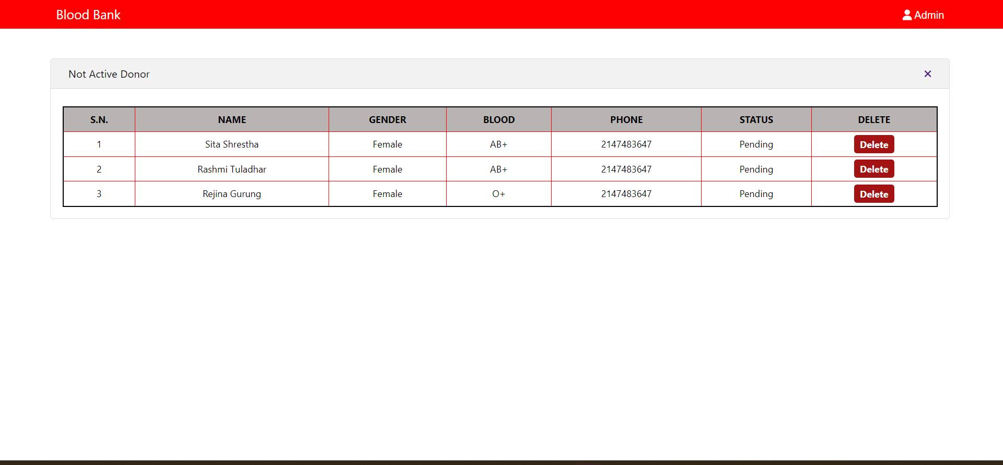

Not Active Donors

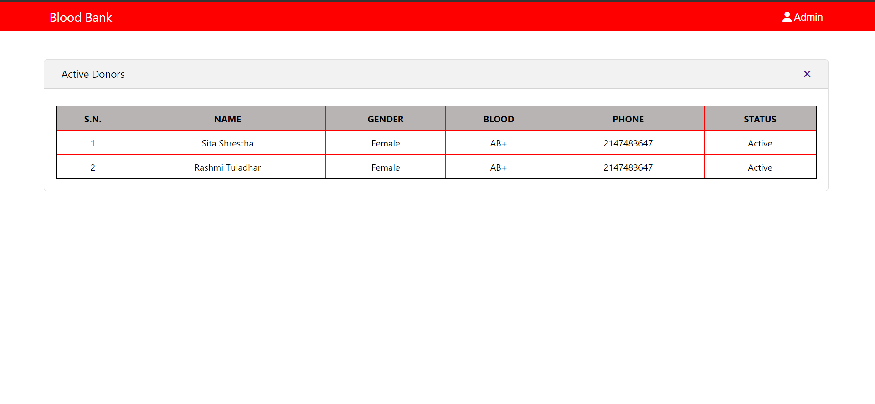

Active Donors

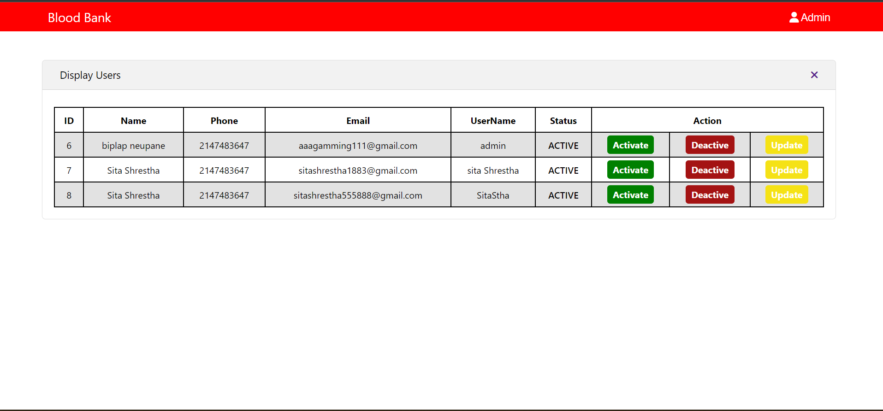

Total Users

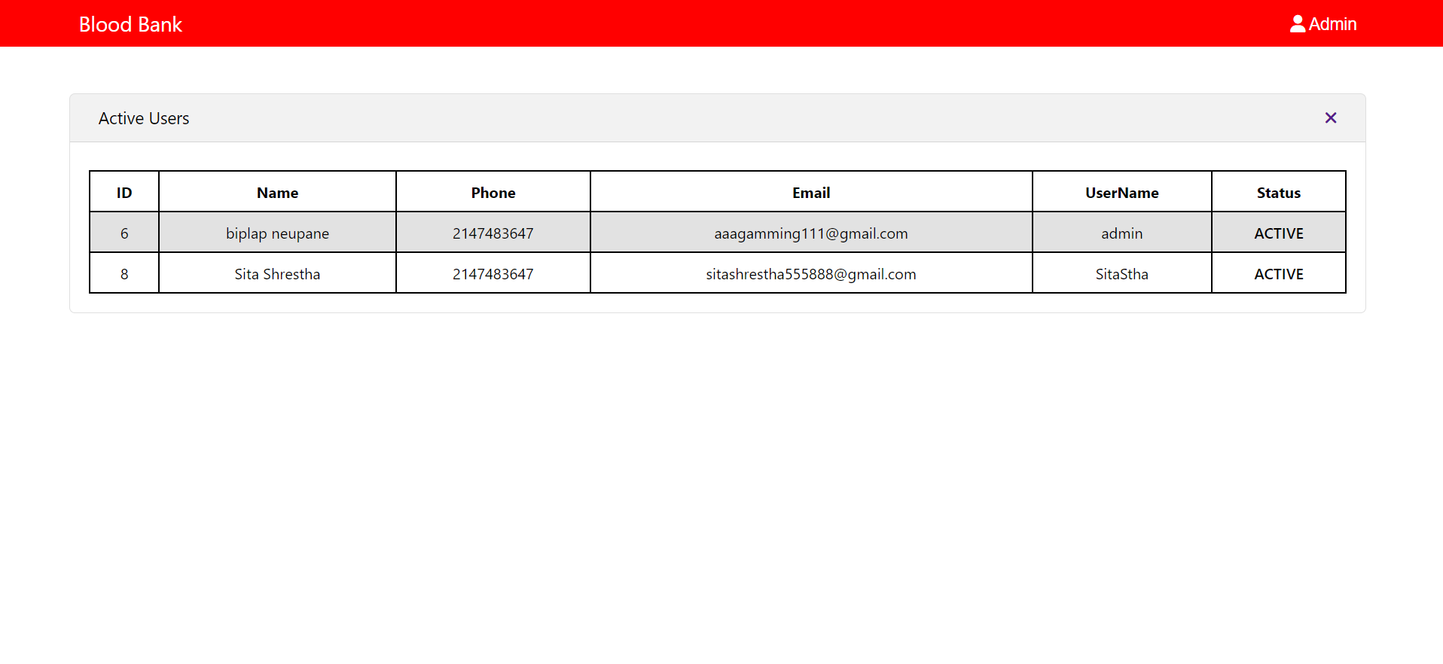

Active Users